IB Freshwater – Regional Water Conflict in the Middle East.
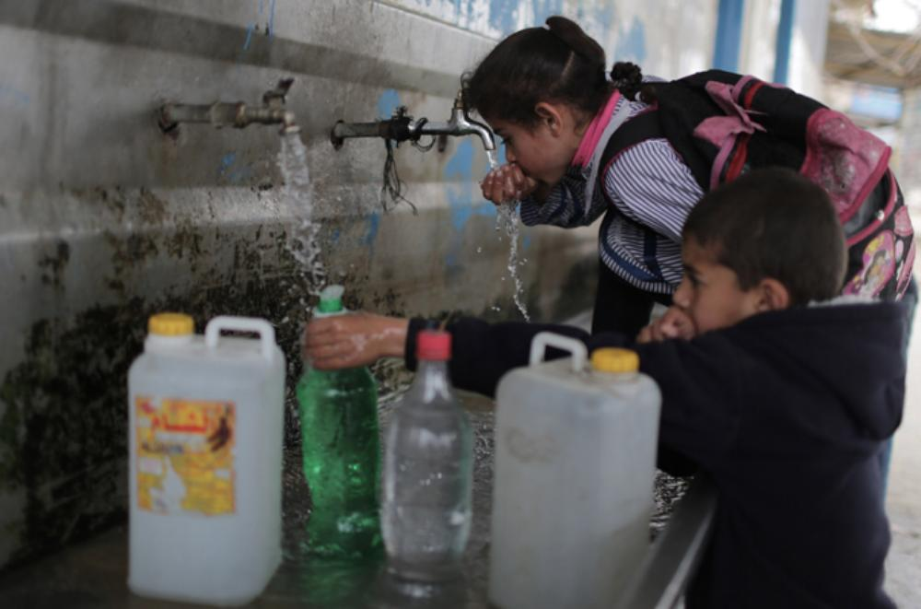
Task 1 – Using the weblink on Geographypods, outline beneath three areas in the world that are experiencing water unrest.
Drainage Basin / River | Country in conflict 1 | Country in conflict 2

Task 2 – Complete the boxes below using one fact and one piece of data from each of the sections of the BBC News article hyperlinked on Geographypods.
Locational Information:

Population Centre | Refugee Centre
Blockade | Borders & Crossings
Militants:

Task 2ii - ii. Create an accurate sketch map to show the location of Israel and the Gaza strip

Task 3 - make comprehensive notes on the issues surrounding the competing demands for water in Israel and the Gaza Strip. Try to make as many links as possible between the physical scarcity of water in this arid area, the physical position of Gaza (positioned between the sea and Israel) and the restrictions in place at the borders of the Gaza Strip.
Continued ……..

Explain the causes and effects of a recent regional/national water conflict. Evaluate the strategies implemented to minimise its impacts. (10)
Suitable Starter:
Water in the Middle East is both a contentious issue and valuable resource which is facing severe depletion. It is an underlying source of tension in an already hostile conflict between the residents and leaders of the neighboring territories of the Gaza Strip and Israel.

Show understanding of what the question requires
This essay will examine the causes and effects of this water related conflict and to discover to what extent the situation is being managed and how effective these intervention strategies are.

Outline
1. Causes of the conflict between Israel & Gaza
2. Effects of the conflict on the people and their water supply
3. Evaluation of management strategies implemented and adopted by the respective governments.

Complete your response on the next two pages.

