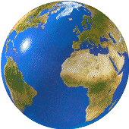You need to use **secondary sources** of information in your investigation e.g. books, newspapers, websites, maps, photographs, diagrams etc. These should be clearly shown...

-You can give a brief credit inside **brackets** at the point in your report where you have used the information. Further details of the source are then given in a **bibliography** which should be in alphabetical order by author’s surname and included at the end of your report. For example:

**A printed source e.g. book, newspaper, magazine etc.**

**In your report:** Author and year of publication in brackets**. Bibliography:** Author, title of book, place of publication, publisher, year.

‘The Cuckmere estuary and coast attracts large numbers of visitors who come to enjoy walking, bird watching, cycling and canoeing on the existing river meanders’ (Miller, 2009)

**Books**

-Miller, Tom. OCR GCSE Specification B Geography. Essex: Heinemann, 2009.

C:\Users\Smith\AppData\Local\Microsoft\Windows\Temporary Internet Files\Content.IE5\2BL7IPZK\MCj04404240000[1].wmf

**A website**

 **In your report-** The website in brackets **Bibliography:** Full internet address of the page used, date accessed.

**Websites**

-Environment Agency- [www.environment-agency.gov.uk](http://www.environment-agency.gov.uk)/news/html. ‘Seaford Shingle Recycling Programme’. (10 May 2010)

In October and February each year, the Environment Agency moves around 60,000 cubic metres of shingle from the eastern and western ends of the beach back to the centre of the beach (environment-agency.gov.uk).

**Maps**

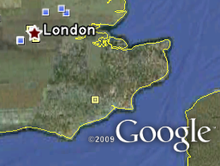 **In your report-** All maps to have titles. Source in brackets. **Bibliography:** Full internet address/Printed Resource/Software

**Maps**

-Google Earth Software.

(Source: Google Earth

Latitude: 50° Longitude: 0° W

Altitude: 41m )