IGCSE Geography – Reducing the risk of river flooding - Hard Engineering

Watch the first video on geographypods and complete the worksheet below. Hard engineering is about creating man-made structures, preventing or controlling floods but can be an expensive option.

Photo | Technique | How it works | Advantages | Disadvantages
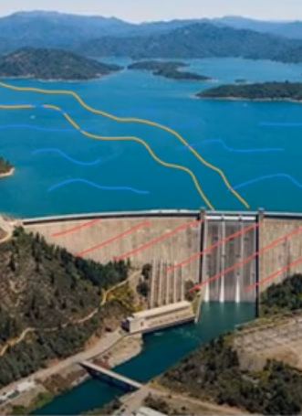

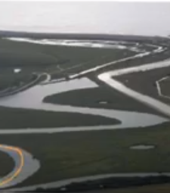

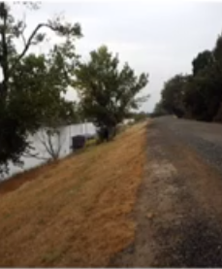

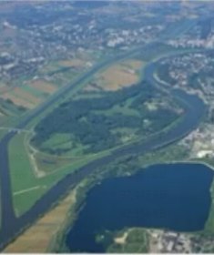

IGCSE Geography – Reducing the risk of river flooding - Soft Engineering

Watch the second video on geographypods and complete the worksheet below. Soft engineering works with nature, reduces or slows water in the channel and is sustainable.

Photo | Technique | How it works | Advantages | Disadvantages
