Grade 7 - Bangladesh Sweatshop Disaster – Geography 5W’s Case Study
What does the picture below show?
Why did the building collapse?

What happened?

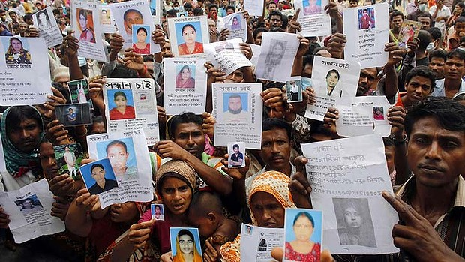
Where did this happen?
We are not a number — not only cheap labour and cheap lives. We are human beings like you. Our life is precious like yours, and our dreams are precious too.
Read more: A Final Embrace: The Most Haunting Photograph from Bangladesh - LightBox http://lightbox.time.com/2013/05/08/a-final-embrace-the-most-haunting-photograph-from-bangladesh/#ixzz2phvdFoyw
Who was affected (number of injured, deaths, key people, gender)?
When did it happen?

