G7 – Primark 360° Tour
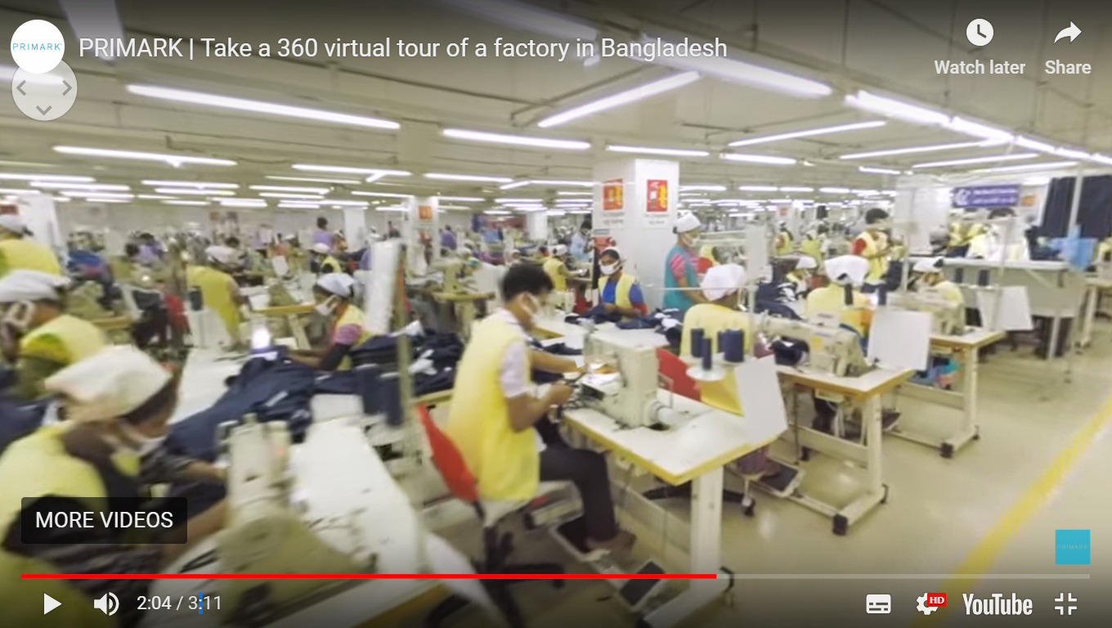

Watch the video embedded on geographypods. Click on the settings button and choose quality 1080s50. Answer the following questions as you take the 360° tour.

- How can Primark sell their products as such low prices?
Reason 1
Reason 2
Reason 3

0.38 – The Cutting Room Floor.

- What % of their factories do Primark share with other manufacturers?

- What does the Primark Code of Conduct demand?

- Stop the video at 1.28. Take a look around the factory. Write a short paragraph to describe what the Cutting Room floor is like, what type of person works here and how it is different from the factory that Meem worked in (and that you drew for homework).

1.33 – The Sewing Floor

- What are the yellow markers on the floor for?

- Stop the video at 1.55. Look right, look left and describe what the Sewing Floor looks like. What type of person works here and how is it different from the Cutting Room Floor?

- Why do people work with no shoes on?

2.10 – The completing section.

- Describe what jobs you can see going on in this section.

- Stop at 2.20 - Why do you think that the workers are wearing masks?

