IB Geography – Prediciting Earthquakes
Comment on the predictability of the following features of the earthquake hazard below by watching both YouTube videos on geographypods.

Element | Possibility of prediction
Time of earthquake | Impossible to predict based on any earthquake monitoring system. Earthquakes can strike at any time making them one of the most deadly hazards.
Date of earthquake
Exact location of epicentre
Fault upon which the earthquake occurs
The magnitude of the earthquake
The economic impact of the earthquake | The economic impact can only be estimated if you run a simulation of different magnitude events striking particular locations with an increasing scale of damage.
The death toll of the earthquake
Notes other methods of predicting the earthquake hazard

- Radon gas emissions -

Earthquake Frequency – Making Sense of the patterns
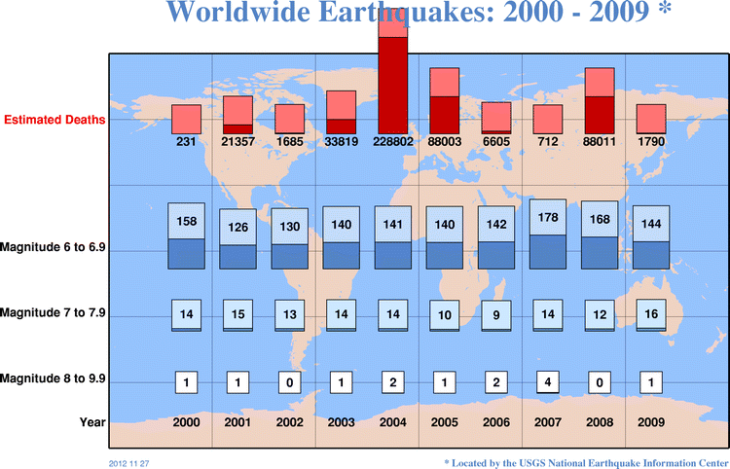

- Study the graph above and comment on the relationships shown.

- Which earthquake event accounted for the extremely high death rate in 2004?

- 2007 saw 4 of the most powerful earthquake events yet it was one of the least fatal years. What combination of factors may have caused this?

IB Geography - Exam Corner
Use the graph on geographypods that shows earthquake events from 1990 – 1999 to compare to the graph on the previous page. Then complete the following IB style response:

"There were more deaths from earthquakes in the last decade than the one before so earthquakes are becoming more common." (5)

The 2000’s were a particularly restless time period for planet earth. The decade saw the occurrence of 12 magnitude 8+ earthquakes and single event hazards, most notably the Boxing Day (26 December) 2004 Indian Ocean earthquake and subsequent tsunami caused a huge number of deaths alone. However, does this period of time that proved to be fatal for hundreds of thousands of vulnerable people also signal that the number of hazardous earthquake events is increasing? ……..

