IGCSE Geography – Population Growth & Distribution
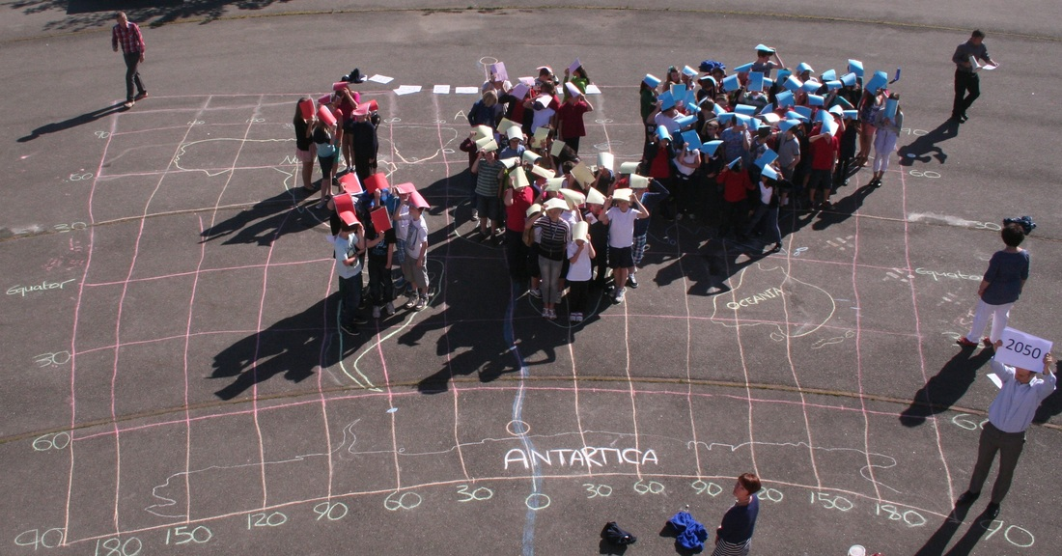
Task 1 – Using Geographypods, note down the five reasons why the population growth rate has started to slow.
1

2

3

4

5

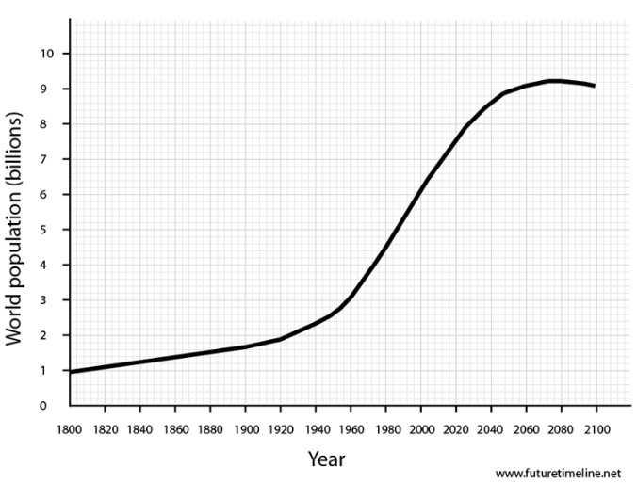

Task 2 – Study the graphic below and the figures from geographypods. In the space underneath, explain which are the three most populous countries in this circle and the implications that this has for population growth.
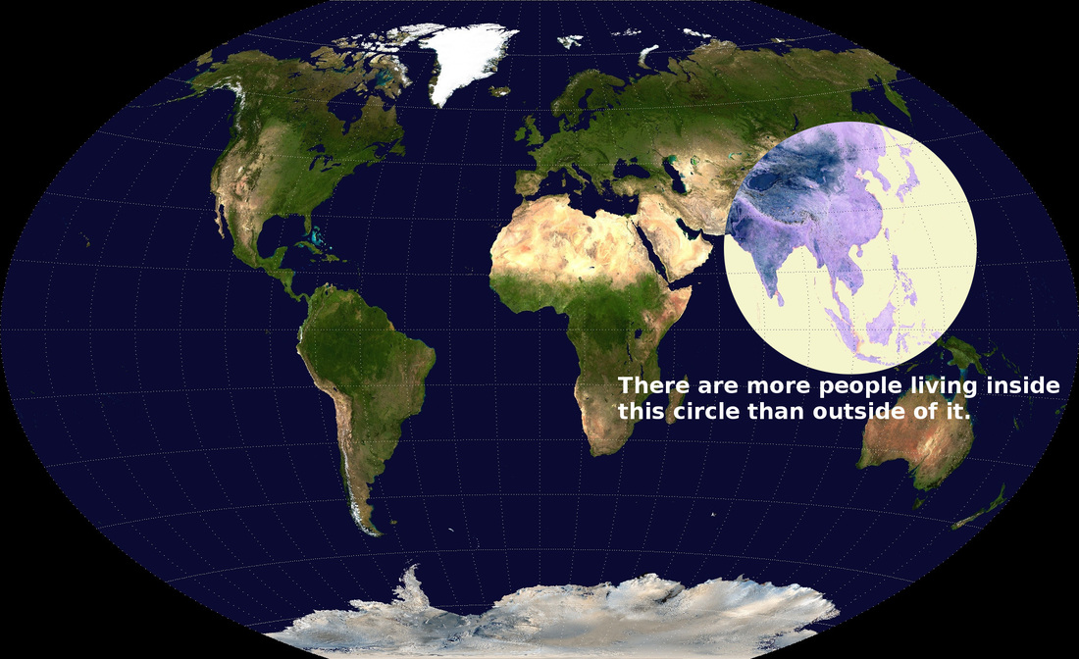

Task 3 - Define Population Distribution

Task 4 - Define Population Density

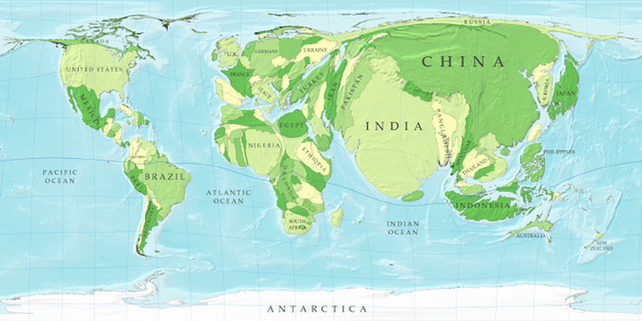

Task 5 - Write a detailed description of the spatial distribution of the world’s most populous countries. Try to identify countries that have swelled hugely and those that have almost disappeared. Name your home country and describe its new shape.

Task 6 – Using the embedded interactive population map on geographypods, describe the global trends for population growth. If you click on regions, it will also give you key population data as well as the 2050 population as a multiple of what is was in 2017. Any surprises?

