IGCSE Geography – How do plate movements cause earthquakes?
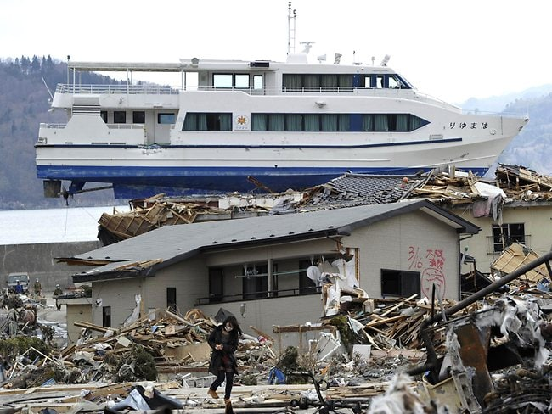
Which country was this picture taken in and how did the boat get there?

Watch the earthquake animation video on geographypods from 1:20. Annotate the diagram below to show how a conservative plate boundary causes earthquakes to happen.
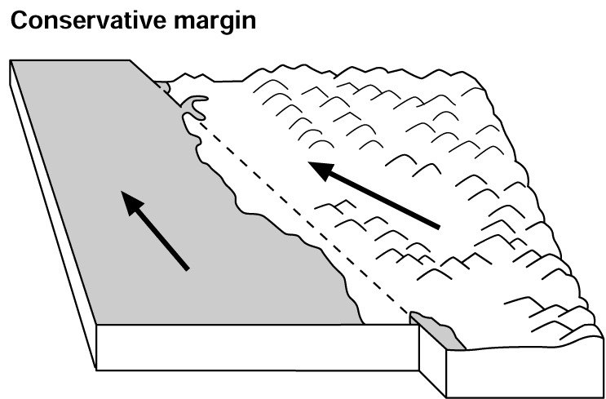

Now go back to your A3 volcanoes sheet and make a copy of this diagram (using a pencil and a ruler) and then complete the 100-word summary to explain how conservative plate margins can cause earthquakes.

Define the following two terms in the space below.
Focus of an earthquake.

Epicentre of an earthquake.

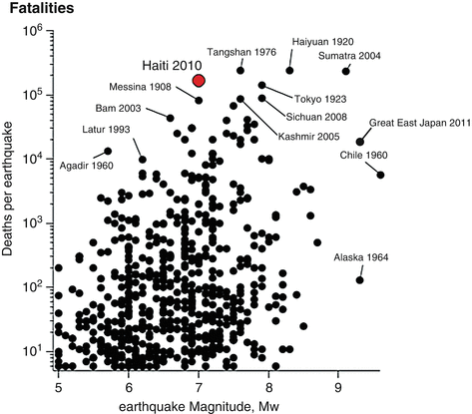
Study the chart above. It plots the magnitude of earthquake events (x-axis) against total death toll from that earthquake (y-axis). Describe the relationship shown on the graph.

Effects are often classified as primary and secondary impacts. Primary effects occur as a direct result of the ground shaking, e.g. buildings collapsing. Secondary effects occur because of the primary effects, e.g. tsunamis or fires due to ruptured (burst) gas mains.

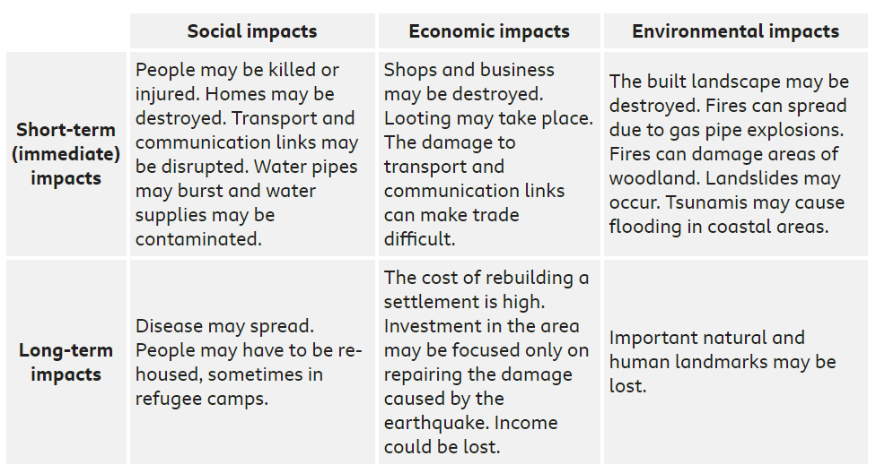
Using the video on geographypods, create a spider diagram in the space below that explains the factors that affect the impact of earthquakes.

