**The Nike Debate (Filmed Version) – Should Nike Change its approach to Global Sourcing?**

The Nike Executives and USA Employees (quaternary) - Outline their views & back up with values..

[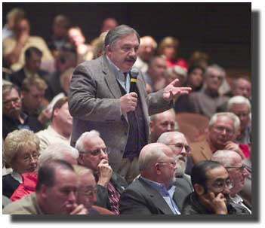](http://news.bbc.co.uk/2/hi/business/7980512.stm)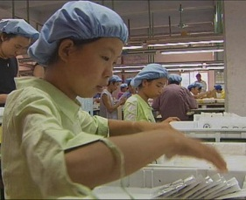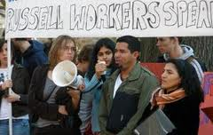****

The Asian Workers (Philippines, Thailand, Indonesia & Vietnam) - Outline their views & back up with values.

The Asian Development Officer - Outline their views & back up with values.

The Nike Shareholder (research what a shareholder is and what concerns they may have)

The Activists - Outline their views & back up with values..