RQ1 - Are the two resorts at the same stage of the Butler Model? Evidence Board
Sitges

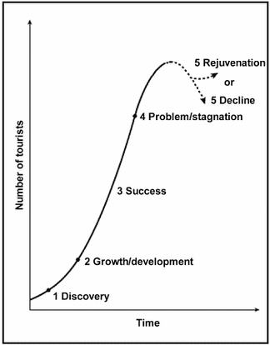

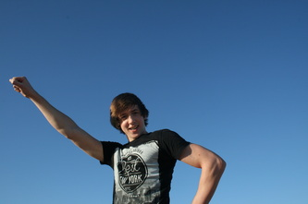

RQ1 - Are the two resorts at the same stage of the Butler Model? Evidence Board
Calafell

