Palm Oil & Me – An Interactive Study
Name:
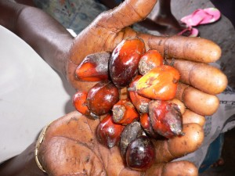
Figure 1Source: oneVillage Initiative/Creative Commons

Task 1 – Go to the Guardian Interactive tool by clicking here
Watch the introduction video and make a list of the different ways we use Palm Oil.
1. You wash with it
2.
3.
4.
5.
6.
7.

It’s in % of what you buy.

Task 2 – How might you have already used Palm Oil today?

Scroll Down To Rainforest
Task 3 - Study the ‘Value of Rainforest – Dead & Alive’ graphic. Complete the table below using the values on the graphic.
Factor | Value Alive / Hectare / Yr $ | Value Dead / Hectare / Yr $
Water Supply
Fisheries
Flood Prevention
Agriculture
Hydropower
Tourism
Biodiversity
Carbon Sequestration
Fire Prevention
Non Timber Forest Products
Timber

Task 4 – What does ‘Carbon Sequestration’ mean? Find a suitable definition that you understand and enter it below.
‘Carbon Sequestration’ means

Task 5 – Choose one of the factors above that is worth more in ‘value alive’ than ‘value dead’ and explain why this is in approximately 50 words.

Task 6 – Choose one of the factors above that is worth more in ‘value dead’ than ‘value alive’ and explain why this is in approximately 50 words.

Scroll Down To Plantation
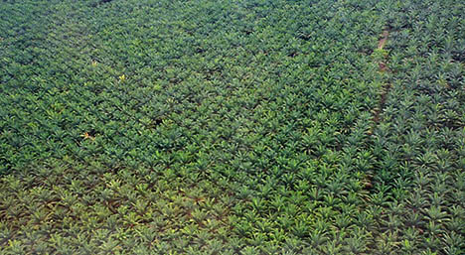
Task 7 – Study the interactive map and time slider. Describe the growth of Palm Oil production between 1964 and 2014. Make sure you name countries.

Task 8 – Which three countries account for the largest production of Palm Oil in 2014 and how much does each produce?

Task 9 – Can Palm Oil be sustainable. Listen to the embedded PodCasts on the site and make notes on whether the experts think that Palm Oil production can be sustainable.
“If you really want true sustainable production... it would be produced by the smallholders on land that they already own, is non-forested and under-utilised in its present state”

Dr Ian Singleton, conservation director, PanEco Foundation

Scroll to Community
Task 10 – Watch the video on how Palm Oil benefits Supriyono and read about how it disadvantages Laskar. Record your notes in the table below

Benefits of Palm Oil Production | Drawbacks of Palm Oil Production

Scroll to Where it Goes
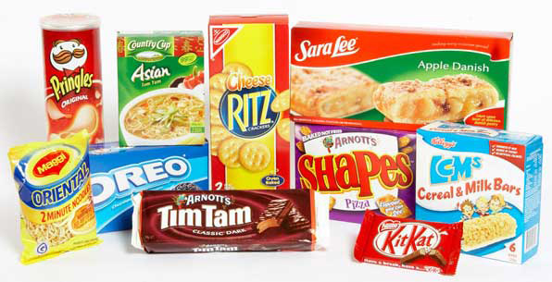
Task 11 – Which are the biggest markets for Palm Oil in 2014 and what is the product used for there?

Task 12 – Study the interactive map and time slider. Describe the growth of Palm Oil imports between 1964 and 2014. Make sure you name countries.

Task 13 – How much of the Palm Oil that is produced is sustainable?

Task 14 – Click on the ‘Read More’ tab and find out what RSPO & CSPO stand for.
RSPO stands for

CSPO stands for

Scroll Down To ‘Business’
Task 15 – Study the pie chart carefully before answering the following questions:

- Which company uses the most Palm Oil annually?

- What sorts of products does this company make? (click here for help)

- Which company uses the most ‘certified sustainable’ Palm Oil?

- Which company uses the least ‘certified’ Palm Oil?

- Which two companies refuse to divulge information about their Palm Oil usage?

Task 16 – Carry out a short investigation into a company that uses Palm Oil responsibly. How do they do this?

Task 17 – Carry out a short investigation into a company that uses Palm Oil irresponsibly. What is being done about it?

