Why is Australia Underpopulated?

Causes | Impacts

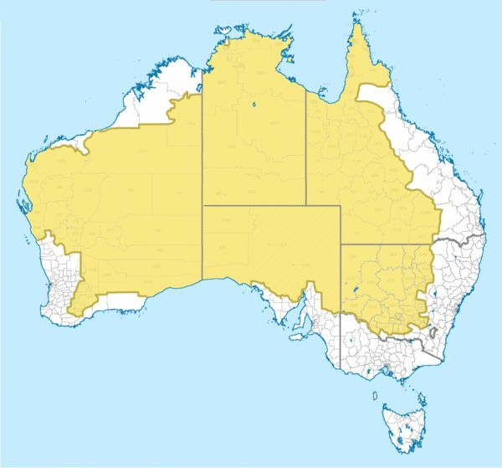

Definition of underpopulation
Under population is when there is more resources than the inhabitants can use in an area. The place could support more people.

Why is Bangladesh Overpopulated?

Causes | Impacts

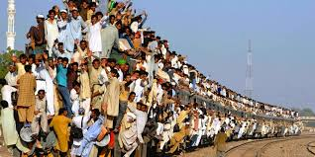

Definition of overpopulation
Overpopulation is when there are not enough resources for the inhabitants in an area.

