International Water Conflict
My teacher: Effort ________/20 IB Level ______
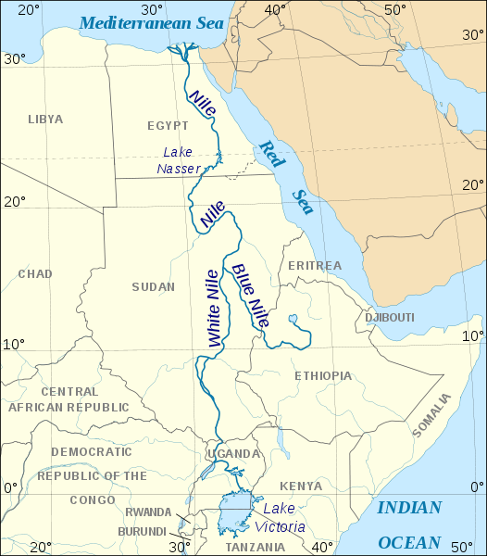
Nile Conflict – My IB One2One Lesson
Annotate Map…

Why?

Key data

What?

Key data

Where?

Key data

Management Strategies

Key data
When?

Key data

Key data

Who?

Key data

