IGCSE Geography – Population & High Birth Rates in Niger
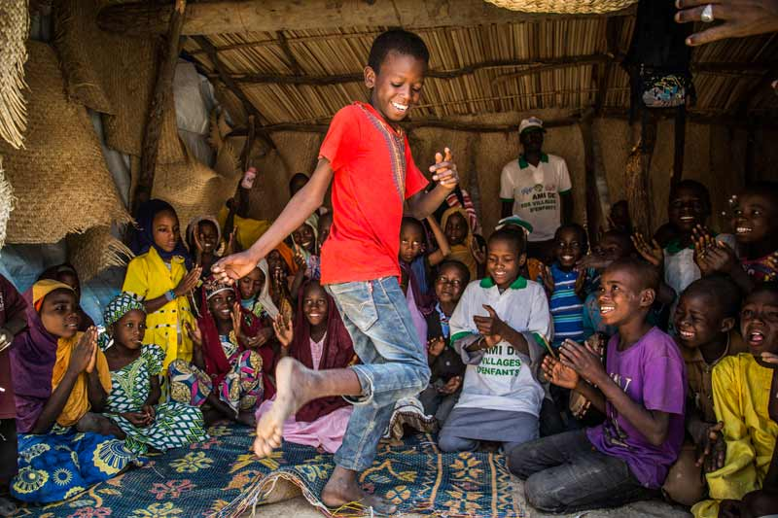

In the space below and using the information on geographypods, create a spider diagram showing the five factors that can cause a high birth rate in a country

Describe the location of Niger in Africa using the map to the right. | 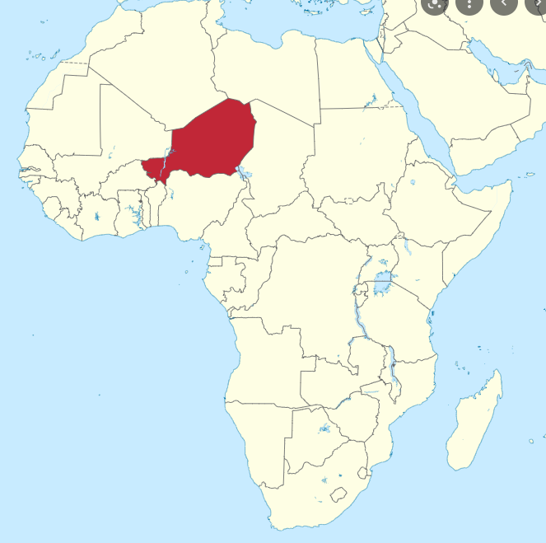

Describe what you think life might be like in this part of the world

What is the population growth rate of Niger?

By the year 2050, what is the population of Niger going to do?

What is the fertility rate of Niger?

What % of the population of Niger is under 15 years old?

What does the mother say about why she has many children?

What are the pros and cons of high birth rates and population growth in Niger?
Pros (advantages) | Cons (disadvantages)

