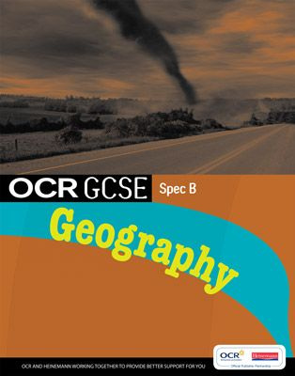
GCSE Geography OCR B
Mock Examination April 2012
You will be sitting your mock examination on Monday 23 April 2012
14h00 – 15h30
Part 1 Tectonics
You need to follow the same principle as your previous mock examination. Case studies should be polished up on for the following hazards:
Hazard | Case Study
Earthquake MEDC | California & San Francisco
Earthquake LEDC | Haiti
Volcano MEDC | Mount Etna, Italy
Volcano LEDC/NIC | Nevada del Ruiz, Columbia
Hurricane MEDC | Hurricane Katrina, USA
Typhoon LEDC | Cyclone Nargis, Myanmar

Go through your orange revision booklet and refresh your memory on the causes, effects and responses to each of the hazards above. Don’t forget to look at how each hazard can be predicted and/or monitored.
Part 2 – Economic Development - You will be tested on what you have learnt so far in the Economic Development section of the course. Fill in the relevant sections in your new orange revision booklet and be sure that you know and understand the following:
Can you:
- Explain how quality of life is calculated?
- Define GDP?
- Define birth rate, death rate, fertility rate, life expectancy, HDI, literacy rate, infant mortality rate, GNH?
- Give examples of different types of aid and some advantages and disadvantages of each?
- Give a case study example of an aid project in an LEDC and how it works to help people there? Can you evaluate its success?

You can! Great. Then you should do amazingly well in the exam. Enjoy your holidays and don’t forget to contact me via our Facebook page if you have any questions. Remember, all of the work that we have done so far is on the geographypods.com page and you have the interactive café section of the online textbook with example questions. Bon courage people.

