Migration to Mexico City
Year 8 Geography
 | Push Factor | Pull Factor
Pedro

Janine

Zina

Maria

Carlos

Taxa

Complete task 5a & b here

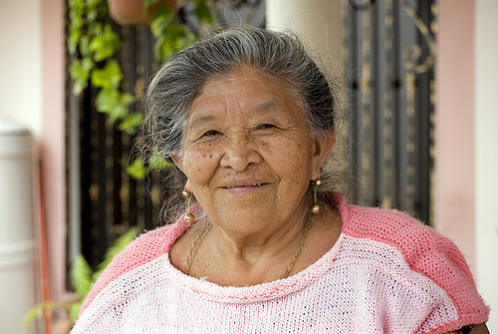
Taxa

