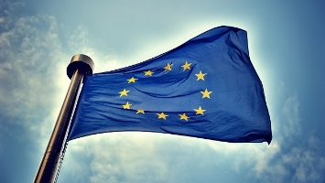
The #Refugeecrisis in the EU
How does this event make you feel?

Write your initials next to the person that most reflects your feelings about the current refugee situation.

