IGCSE Geography – Measuring the Weather

Task 1: complete the table below using the information on geographypods and Google.
Name of the instrument | Photo or diagram | What it shows | How to read it
A | 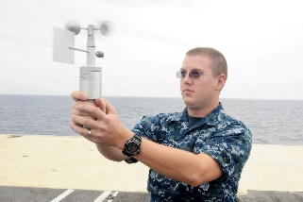
B | 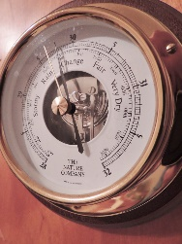
W V | 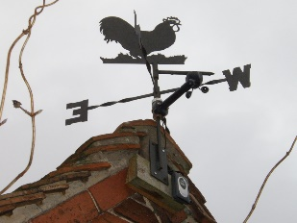
H  Or  D B  W B  Thermometer | 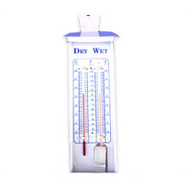
M  M  Thermometer | 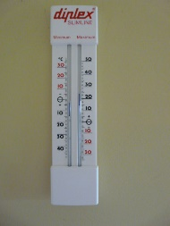
R G | 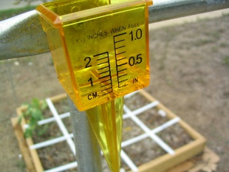

Stevenson Screen
Task 2 – Annotate key information on to the diagram below using the resources on geographypods.

