IGCSE Geography - Measuring Cloud Cover
The scale used to measure cloud cover by meteorologists is called _____________
It divides the sky up into _____________
Task: Fill in the table below using the information on www.geographypods.com
Circles | Cloud Cover

Interpreting Weather Circles
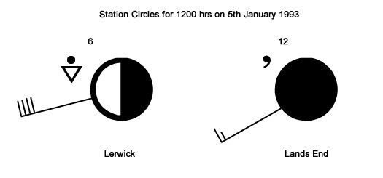

Using the information on www.geographypods.com write about the current weather conditions at Lerwick & Lands End, two places in the United Kingdom.
Lerwick:

Lands End:

