MC Glocalization – McDonalds in India
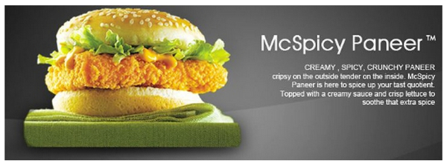

Define ‘Glocalization’

Read the BBC article on geographypods - How McDonalds has "conquered" India. Then complete the following tasks:

Task 1 - What were the major issued faced by McDonalds in setting up the restaurant chain in India? Talk about eating habits and levels of poverty.

Task 2 – Outline the plans for future McDonalds development in the country. State population numbers compared to McDonalds outlets.

Now visit the global McDonalds site and navigate your way to India (see geographypods).

Task 3 - Comment on the types of burgers available and the level to which they have been glocalized for the Indian market.

Task 4 – Comment on children promotions and their socio cultural impacts on the target audience

Task 5 - Now navigate to the YouTube McDonalds channel for India and watch at least two videos making notes on the use of imagery and music to sell the glocalized products.

