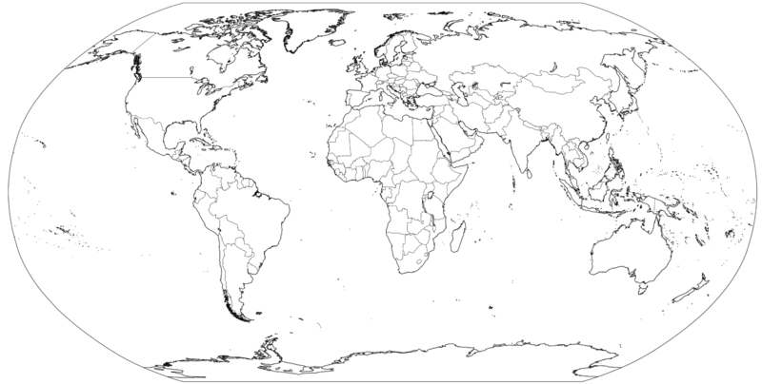
Task 3 - Mapping the Brazil 2014 World Cup Finalists

Comment on the distribution of World Cup participants at the 2014 World Cup. Are there any places where lots of teams come from or very few teams? Why might this be?
North America – Red
South America - Green
Europe - Blue
Africa - Yellow
Asia - Orange
Oceania - None Qualified

