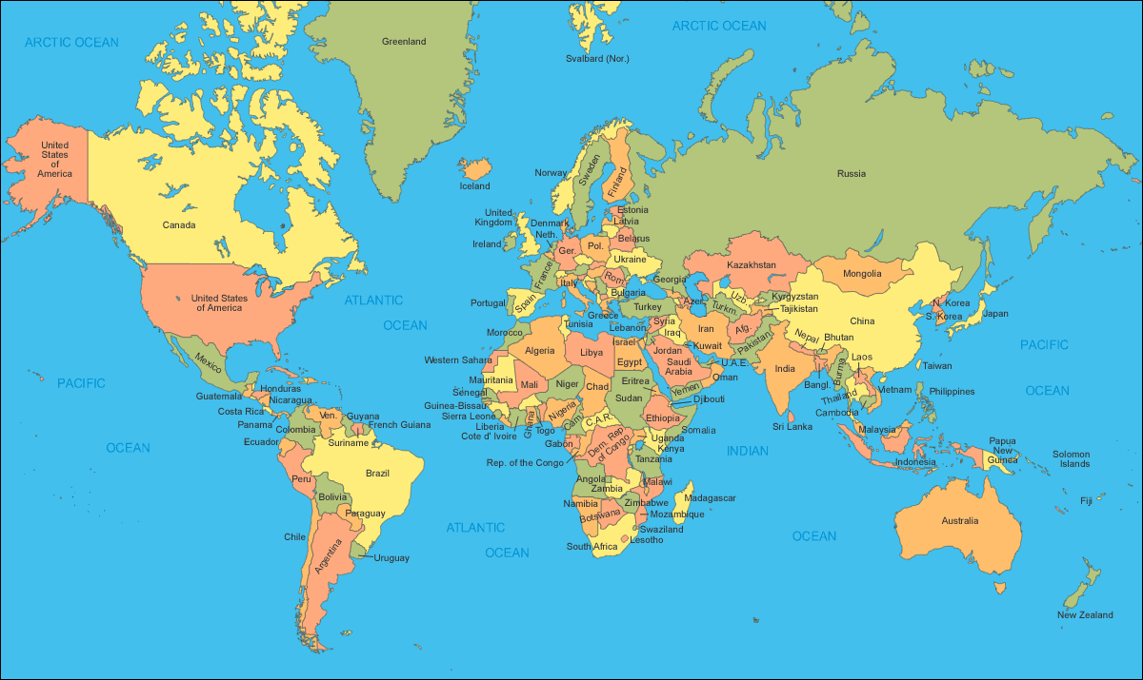
Major Movements of People Over Time – IB Geography Core Patterns & Change

