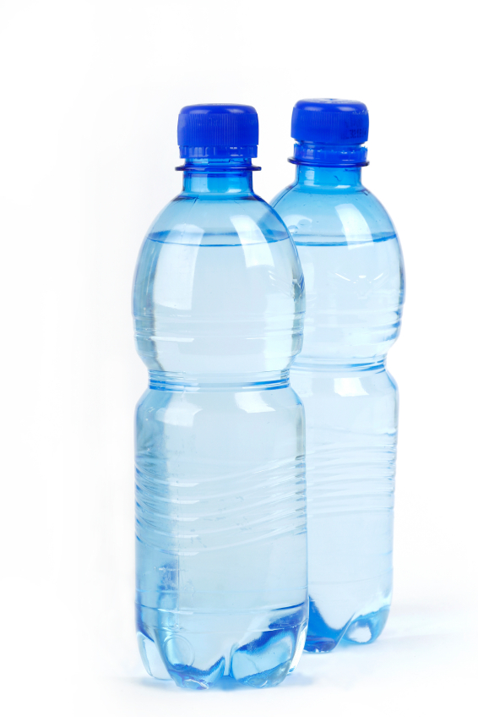
Losing Our Bottle – Year 9 Geography

Five good reasons to need water (apart from staying alive)

1.
2.
3.
4.
5.

Thoughts about Water Videos
Video 1 – Roller Babies

Video 2 – Powerful Pedalo

Video 3 - Melting

Video 4 – Crazy Volcano

Can you taste le difference?
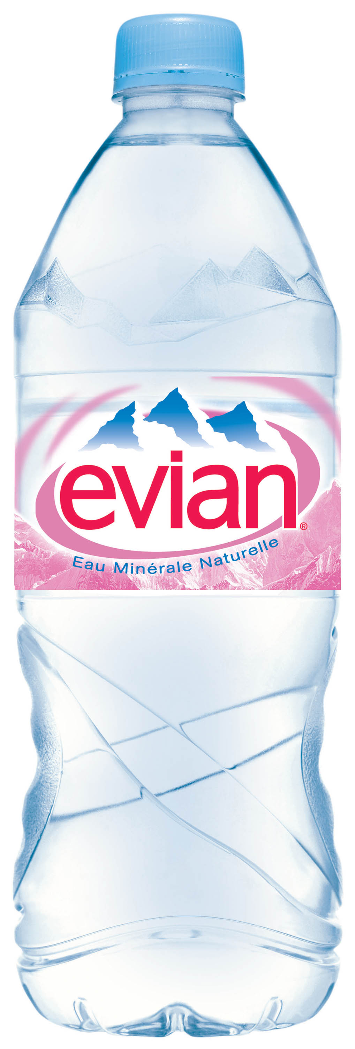
The Taste Test The real result

Evian

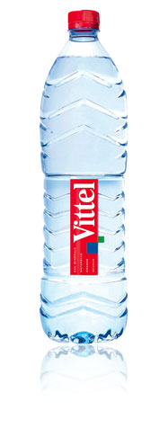

Vittel
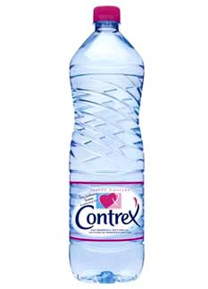

Contrex

IST Tap

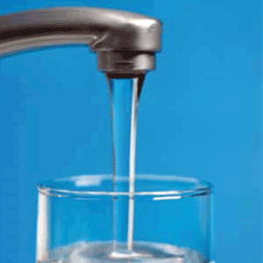

Score out of 4

Research Homework

Count the number of bottles of water in your house. How many are there?

Who drinks bottled water in your household?

On your next visit to your local supermarket, how many different brands of water can you count on the shelves? Are there any brands from outside France?

Feel free to do a taste test with people at home and bring in the results.

