IGCSE Geography – Where and why do earthquakes & volcanoes happen?

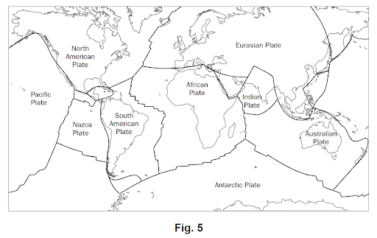
Task: Using the list on www.geographypods.com, plot the locations of the famous volcanoes onto the plate map below.

Key
Volcanoes –
Earthquake Events -

Sketch diagram & labels to show plate movement / volcanoes | 100-word explanation to explain the location of volcanoes.

