IGCSE Geography – High Tech Industry - Locating Airbus in Toulouse
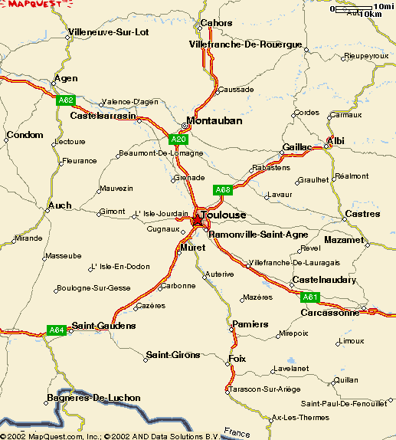
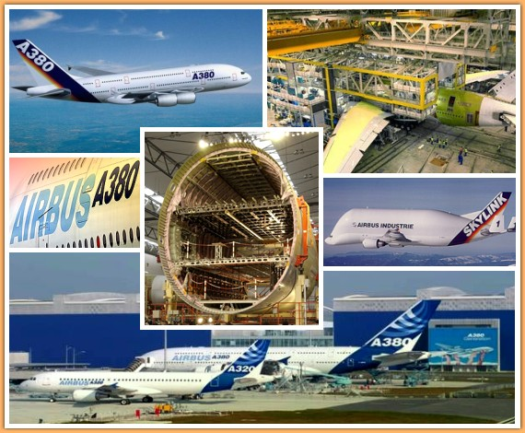
Labour (workers)
Marketplace
Location
Existing Industries
Conglomoration
Universities
Transportation

