5. Leisure at the national/regional scale: Ligue 1

Task 1 - Introduction to Ligue 1 – France (100 words)

Task 2 – Locating the participant teams
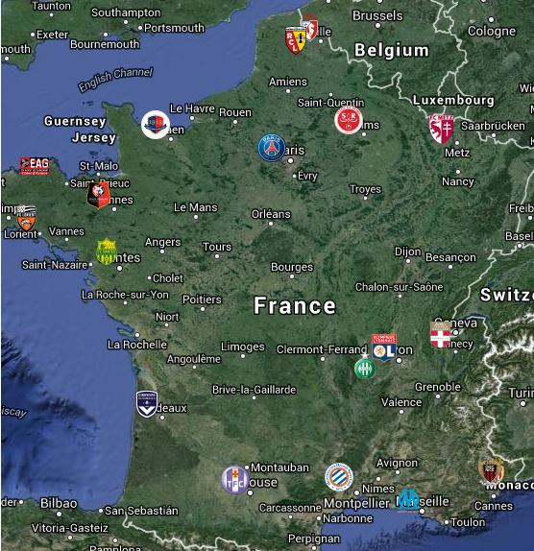

Describe the spatial distribution of teams in Ligue 1 in France.

Task 3 - Prior Hierarchy of the Teams

Season | Champions | Runner Up | Third Place
2007-08
2008-09
2009-10
2010-11
2011-12
2012-13
2013-14

Compare the recent winners of Ligue 1 with the most successful clubs over time.

Task 4 - Complete a piece of writing about the attendances of the top three clubs (and Toulouse)
Olympique Marseille -

Paris St Germain -

LOSC Lille -

Toulouse FC -

Task 5 – Stick your satellite image of the stadium location beneath

Why is your chosen Ligue 1 team located where it is within the settlement? Don’t forget to use the Toulouse example.

Task 6 – Why does L’OM (Olympique Marseille) have an overseas branch of the supporters club? Link to current season performance, past successes, sphere of influence etc.

Why does Toulouse FC not enjoy such a wide base of fan support outside of France?

Task 7 – Exam Corner
With reference to specific examples that you have studied, explain the relationship between team location and the residence of its supporters. (10)

