G7 Geography - ​Does the USA need a 3,145km long border wall?

Task 5 – Use the maps and charts on geographypods as well as the information on this sheet to complete the following questions.
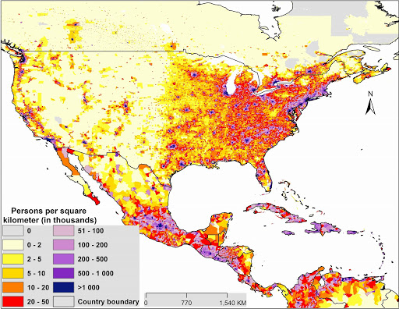

The map above shows the population density of the USA and Mexico. How is population density measured?

Describe the population density of the USA. Can you give any reasons for these patterns?

Describe the population density of Mexico. Can you give any reasons for these patterns?

Describe the population density along the USA / Mexico border. Where is the population density highest and where is it the lowest?

Go to Google Maps and find your way to the USA / Mexico border then turn view to satellite. Try to explain at least two reasons why low population densities are found along the border.
1

2

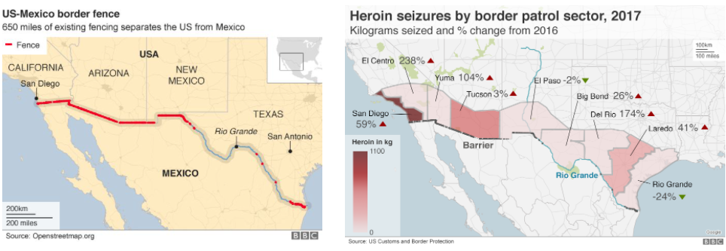
Using the maps above (larger versions on geographypods) and your knowledge of population density, explain why the wall only exists in certain places along the border.

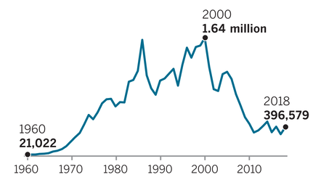
The graph above shows ​U.S.- Mexico border apprehensions over time. Describe the patterns and trends on the graph between 1960 – 2020.
In 2018, approximately how many people were being apprehended every day?

Tweet Trump – As you know, Donald Trump was a big fan of Twitter (before he was blocked!). With what you have found out so far, please write a 280-character tweet to Donald Trump explaining whether a wall all along the 3,145km length of the USA – Mexico border is really needed.

Remember - 1 character = 1 word or one space – you can check this in Word by selecting the text – Review – Word Count – Characters (with spaces).

