World Cup 2022 – What is the climate like in Qatar?
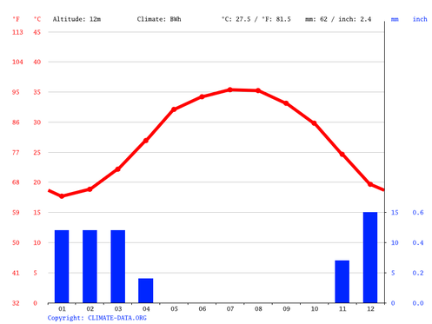

The graph above is called a climate graph. It shows two features of climate – temperature (red line) and precipitation (blue bars). The x-axis shows you the months of the year e.g. 04 = April. There are two y-axes, one showing temperature (use °c) and the other showing precipitation (use mm). So, you should read the red line graph on the left x-axis and precipitation on the right x-axis.

Using the graph above, describe the annual climate conditions in Qatar. You should refer to months as well as temperatures and precipitation totals in your description.

Normally, the Football World Cup happens in the summer months of June / July. However, for the first time ever, they are happening in November & December in Qatar. Why might this be?

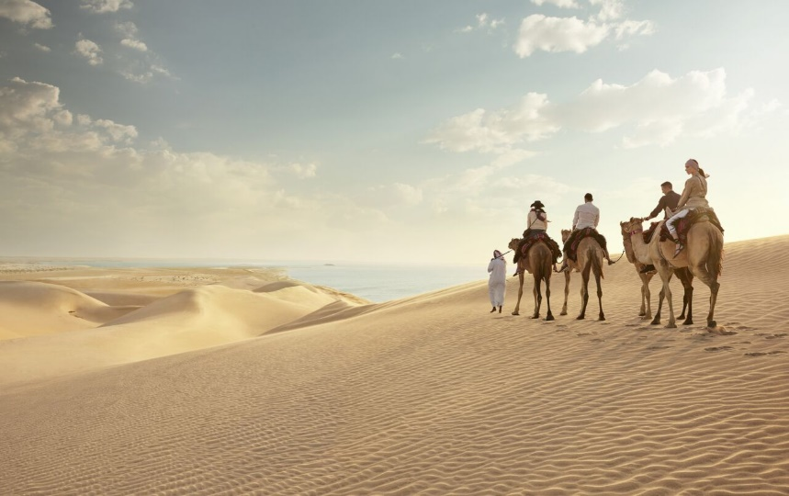

The photo above is taken from the Qatar tourism website. It shows a photo taken in Qatar. Describe the photo in the space below.

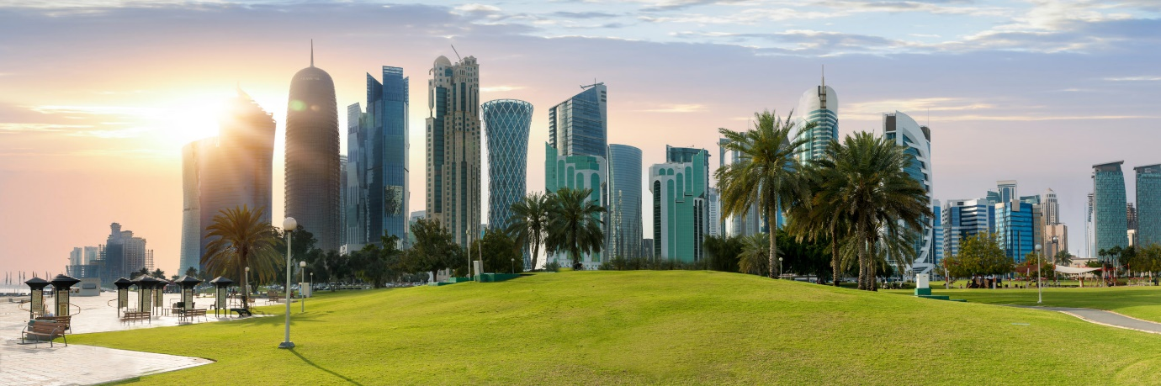

The photo above is taken from the Qatar tourism website. It shows a photo taken in Qatar. Why might this photo not be what you may expect to see in Qatar?

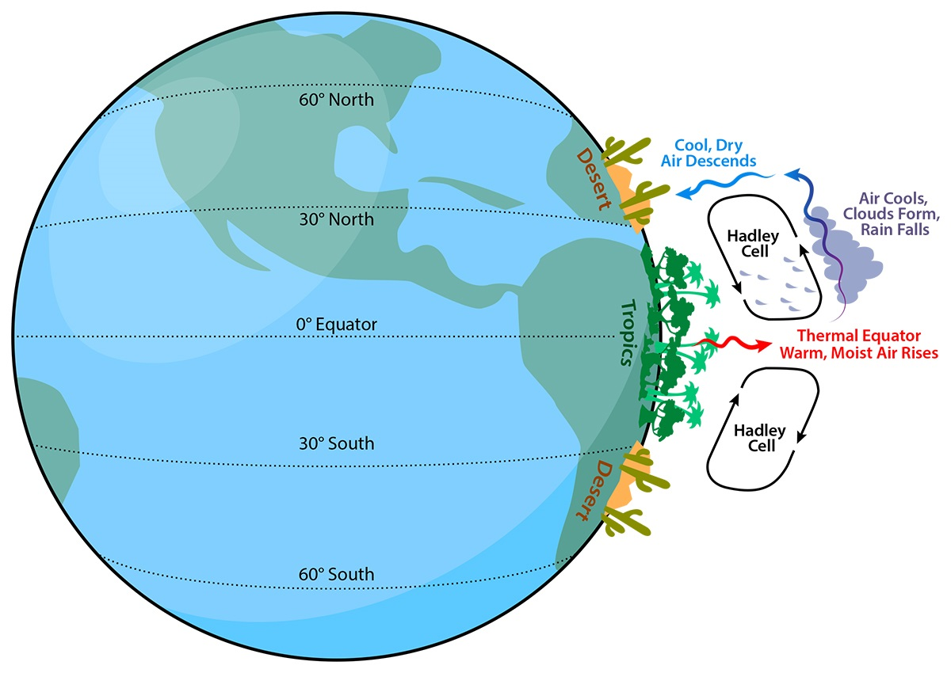
Source: Arizona State University
Study the image above and watch the embedded video on geographypods. Qatar is found at a latitude of approximately 25° north. Try to explain in the space below why Qatar has such a dry climate whereas around the Equator, it rains a lot more.

