Introducing IB Leisure, Sport & Tourism
Case Study – Me!
Me & my leisure time
Me & Sport

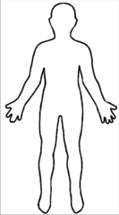
What is leisure time ?
Me & Tourism

