IB DP Geography – Global Interactions – Socio Cultural Introduction

Define ‘Culture’

On the map beneath, highlight and label the major global cultural hearths using the information on geographypods.
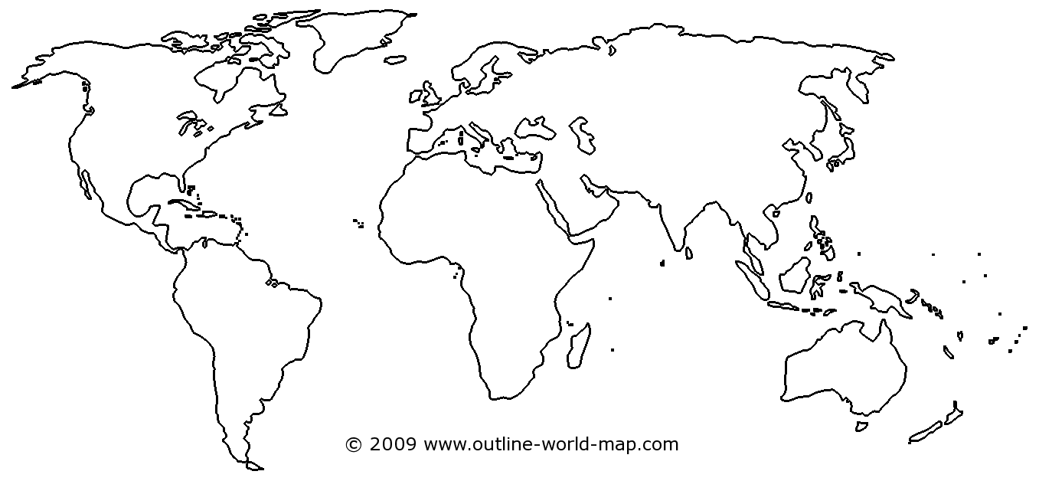

Task 1 – Watch the Karl Pilkington video and fill in the relevant gaps below to show clashes of cultural traits between British & Chinese in terms of diffusion by tourism.

Language | Customs | Beliefs | Dress
Images | Music | Food | Technology

Task 2 – Watch Whopper Virgins 7 minute video on geographypods. Take notes below on how food can be diffused by an international movement of people. What are the reactions of people to both burgers? Study the credits at the end. Do any of the countries surprise you?

Task 3 – Watch 'Scandale au Pays du Cassoulet' and take notes on the resistance to food globalization experienced by the actors.

