Landforms of erosion: u-shaped valleys and truncated spurs

- Add the labels below to the diagrams by writing them around its edge and adding an arrow to point to where they are located. The first is done for you as an example.

Wide, flat bottom floor | Truncated spur | Narrow valley floor
Winding valley | Interlocking Spur | Straighter valley

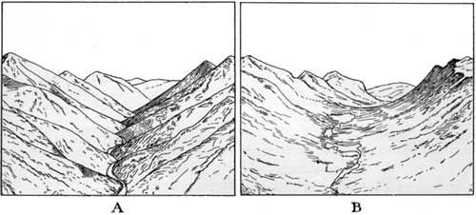

Wide, flat bottom floor

- Complete the ‘fill in the blanks’ below to explain the formation of u-shaped valleys and interlocking spurs

BEFORE Glaciation

___________________ valleys exist with rivers that wind past hard and soft rocks to form

___________________ spurs.

DURING Glaciation
Glacier fills the valley and moves downhill under ________________. Its power

______________ any rock in its path. Interlocking spurs are therefore cut back to form

________________________ spurs.

AFTER Glaciation
U-Shaped valleys are left with characteristic features of steep walls of bare rock and

__________bottoms. They are _________________ than v-shaped valleys before.

Missing words: gravity; erodes; truncated; flat; v-shaped; straighter; interlocking
M
Landforms of erosion: u-shaped valleys and truncated spurs

- Add the labels below to the diagrams by writing them around its edge and adding an arrow to point to where they are located. The first is done for you as an example.

Wide, flat bottom floor | Truncated spur | Narrow valley floor
Winding valley | Interlocking Spur | Straighter valley
Hard rock | Soft rock | Steep rocky sides

Wide, flat bottom floor

- Complete the ‘fill in the blanks’ below to explain the formation of u-shaped valleys and interlocking spurs

BEFORE Glaciation

___________________ valleys exist with rivers that wind past ___________ and ________

rocks to form ___________________ spurs.

DURING Glaciation
A _______________fills the valley and moves downhill under ________________. Its power

______________ any rock in its path e.g. via _________________. Interlocking spurs are

therefore cut back to form ________________________ spurs.

AFTER Glaciation
U-Shaped valleys are left with characteristic features of steep walls of bare rock and

__________bottoms. They are _________________ than v-shaped valleys before.
H

Missing words: gravity; erodes; interlocking; flat; v-shaped; straighter; truncated; hard; soft; glacier; abrasion

