G6 Map Skills - Justin’s Big Day Out!
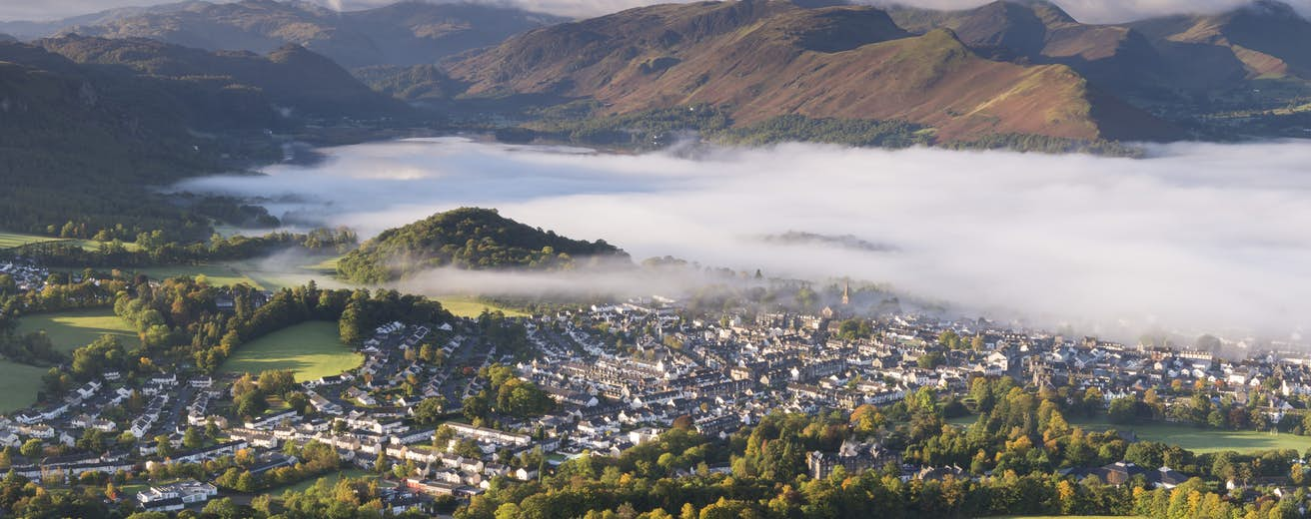
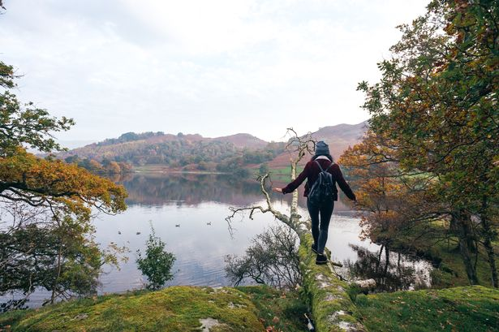

You will need to use the OS 1:50:000 map extract of Keswick in the UK. Plan a 10 step ‘relaxing expedition for Justin’. Your trip needs to start and end in the same place. It should take two days and one night. He needs to spend the night somewhere. It can involve walking, running, biking and swimming.
Step | From: Grid Ref | To: Grid Ref | Direction | Distance (straight line) | Description of this stage of the route.
1
2
3
4
5
6
7
8
9
10

Total distance covered: ____km
Total Difficulty rating _____ /10 (1 easy – 10 impossible)
Enjoyment rating ____/10 (1 superb – 10 the worst thing ever).

