Justin Bieber’s Light Relief!
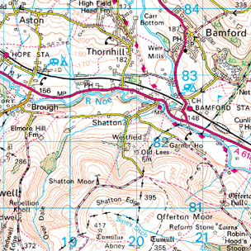
Task – Design a relaxing (?) route for Justin to take in the English countryside. Make it scenic too and don’t forget about relief. You can annotate your adventure around the map.

