Grade 7 – Geography of My Stuff – Journey of a T-Shirt - Notes Sheet
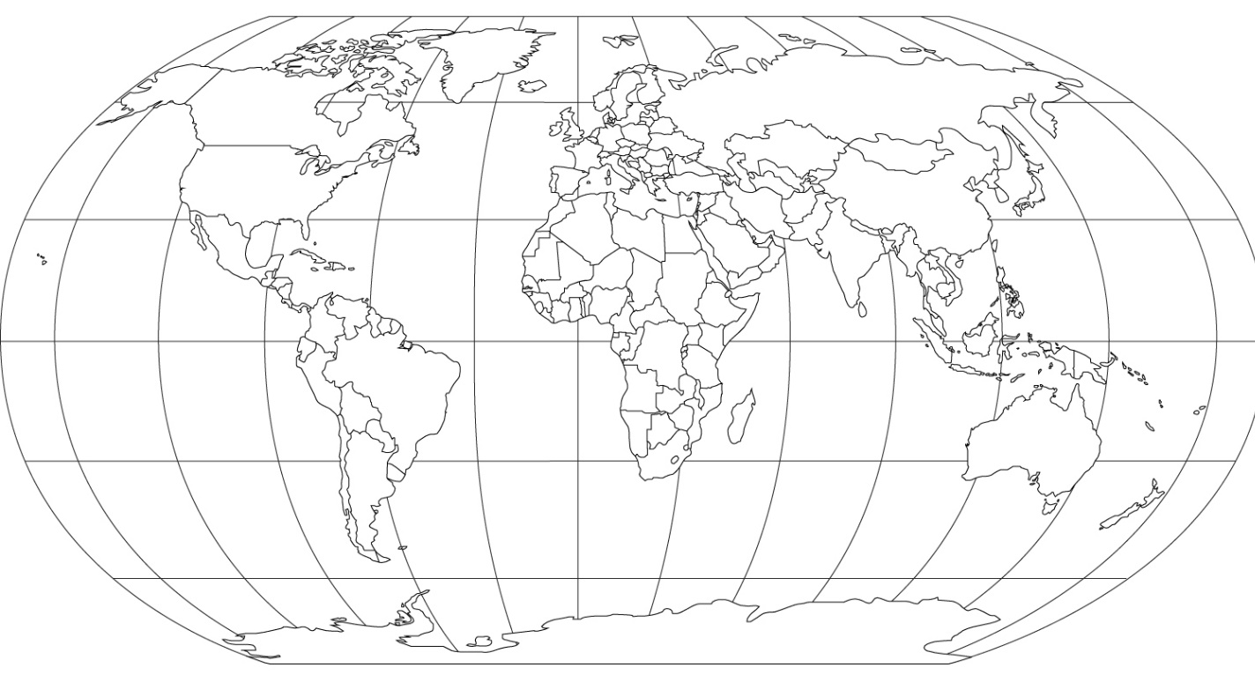

Key – locations and flows of transport.
After you have watched all five videos and taken notes on the following page, you can now label all the locations on the map above and attempt to draw flow arrows to show the production process of a t-shirt from the cotton farm in Mississippi to eventually, where you live.

Video Number | Country(s) Involved | What happens here? | Who are the people involved?
- COTTON
One farmer. A shocking number of T-shirts.

Video Link - here

- MACHINES
Sucked up, laid down and twisted

Video Link - here

- PEOPLE
The lives of the workers who made our shirts

Video Link - here
- BOXES
The unsung innovation at the heart of the global economy

Video Link - here
- YOU  Where our shirt starts and ends — and everyone in between  Video Link - here | No need to take any structured notes here, but possibly enter a quote or two from the people involved in making your t-shirt.

