IB Geography – Hazards & Disasters
Case Study Summary Sheet for Japan Earthquake 2011 (MEDC)
** The Triple Disaster **
Where did it happen?
The magnitude 9.0 2011 Tohoku earthquake struck 30KM offshore of Japan, along a subduction zone where two of Earth's tectonic plates collide. In a subduction zone, one plate slides beneath another into the mantle, the hotter layer beneath the crust. Less than an hour after the earthquake, the first of many tsunami waves hit Japan's coastline. The tsunami waves reached run-up heights (how far the wave surges inland above sea level) of up to 39 meters at Miyako city and traveled inland as far as 10 km in Sendai. The tsunami flooded an estimated area of approximately 561 square kilometers in Japan. The tsunami caused a cooling system failure at the Fukushima Daiichi Nuclear Power Plant, which resulted in a level 7 nuclear meltdown and release of radioactive materials. About 300 tons of radioactive water leaked from the plant every day into the Pacific Ocean.
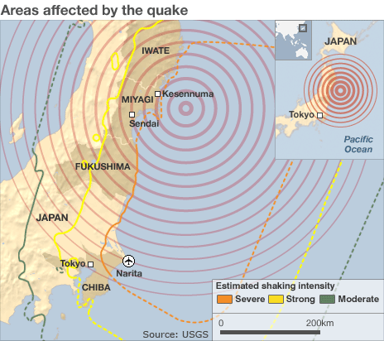

CIA Fact Box – Japan Need To Know
Indicator | Values (2014 estimated)
GDP per capita PPP | $37,100
People Living in Poverty (less than $2 per day) | 16% of the population
Access to Clean Water | 100% of the population (universal)
Life Expectancy | 84 years
Literacy Rate | 99%
People Per Doctor | 2.14 doctors per 1000 people
When did it happen?
Date. Friday 11 March 2011
Time (local). 16.46
Duration. A matter of seconds but since the day, Japan has experienced over 1000 aftershocks, many of which have been over magnitude 6 on the Richter scale.
The earthquake happened in the late afternoon meaning that populations were spread out in risky areas (workplace, home, transportation). No foreshocks had been recorded and no advanced warning had been given of the forthcoming earthquake event but warning was given to coastal areas of the approaching tsunami waves and many people were able to escape to higher ground.
Why did it happen?
Japan is located at the junction of three major tectonic plate boundaries. East of Japan, the Pacific plate moving at 8cm per year subducts beneath the overriding Eurasian plate. This motion pushes the upper plate down until the accumulated stress causes a seismic slip-rupture event. The break caused the sea floor to rise by several meters causing the tsunami to race inland towards the eastern coast of Japan. The quake was the fourth largest recorded since records began and the strongest in Japanese history.
Who was affected by it happening?
Social Impacts | Economic Impacts
A total of 12,431 people were confirmed dead by Japan's National Police Agency, while 15,153 were missing.  A total of 164,059 households in the north were without electricity,  At least 170,000 households in eight prefectures were without running water  Hundreds of thousands of homes, many schools and hospitals, airports and rain infrastructure destroyed. | The tsunami caused dramatic drops in industrial production that imposed a toll not only on Japan’s economy, but also on the many other countries linked through these production networks  The shutdown of the nuclear reactors has had far more damaging long-term economic consequences. Only two nuclear reactors have restarted operations, and the Japanese government has had to resort to large increases in oil imports to make for the gap in electricity supply. Consequently, Japan has experienced record trade deficits, in the order of $78 billion in 2012.
Environmental Impacts | Political Impacts
Portions of northeastern Japan shifted by as much as 2.4 m closer to North America  A 400 km stretch of coastline dropped vertically by 0.6 m, allowing the tsunami to travel farther and faster onto land.  The leakage of radioactive waste from Fukishima into the surrounding air, soil and water caused considerable environmental problems. Fishing ceases in the area. | The financial cost of rebuilding the Tohoku region is staggering (in its latest stimulus budget, the Abe government slated $18 billion dollars for this purpose).  Japan’s energy future is also uncertain as the government has yet to issue a long-term strategy that clarifies the role of nuclear power in the country’s energy mix.  In October 2012, the Japanese government and the World Bank co-hosted the ‘Sendai Dialogue’ to highlight the lessons learned from the disasters and to adopt comprehensive guidance for reducing risk in other parts of the world.

What happened? *Leave this until we complete the next section on risk assessment and adjustments & responses to hazards
Management of the earthquake hazard in Haiti.
Before the event

During the event

After the event -

Planning, preparation, prediction, hazard mapping, evacuation, warnings.

Help with recovery, aid - local, regional and international, role of NGOs.
Rescue (short) Rehabilitation (Medium) Reconstruction (Long)
Task: Some information is included below. Sort into the 3 R’s above and carry out additional research to fill in any blanks that you may have.

Japan is the third-largest economy in the world and is not what people generally imagine when they think of a country in need of large-scale international aid however;

116 countries and 28 international organizations had offered assistance to Japan. As of March 2012, donations to areas affected by the disaster totaled ¥520 billion and 930,000 people have assisted in disaster recovery efforts

Within the first 72 hours, the Kan government had deployed hundreds of thousands of Self Defense Forces to assist with rescue and relief, organized a network of inter-agency committees and task forces, released any funds requested, and attempted to reassure its citizens that everything possible was being done.

Within 48 hours the government had designated a member of parliament (Ms. Kiyomi Tsujimoto – a Social Democratic Party member and former NGO staffer) to serve as the go-between for volunteer/NGO relief activities and government activities.

Save the Children sent emergency response teams to assess the needs of children and their families in the hardest hit areas between Miyagi Prefecture and Tokyo in Japan.

The American Red Cross deployed a disaster management expert to Japan for a week-long mission, where she worked with the Japanese Red Cross (who dispatched 62 response teams within the first 24 hours and have housed more than 300,000 evacuated people) in an effort to best bring relief to affected communities.

IKEA Japan donated 35 various products to 15,000 homes to the Miyagi and Iwate prefectures, the regions most affected by the disaster.

