IGCSE Geography - Introduction to Tropical Storms
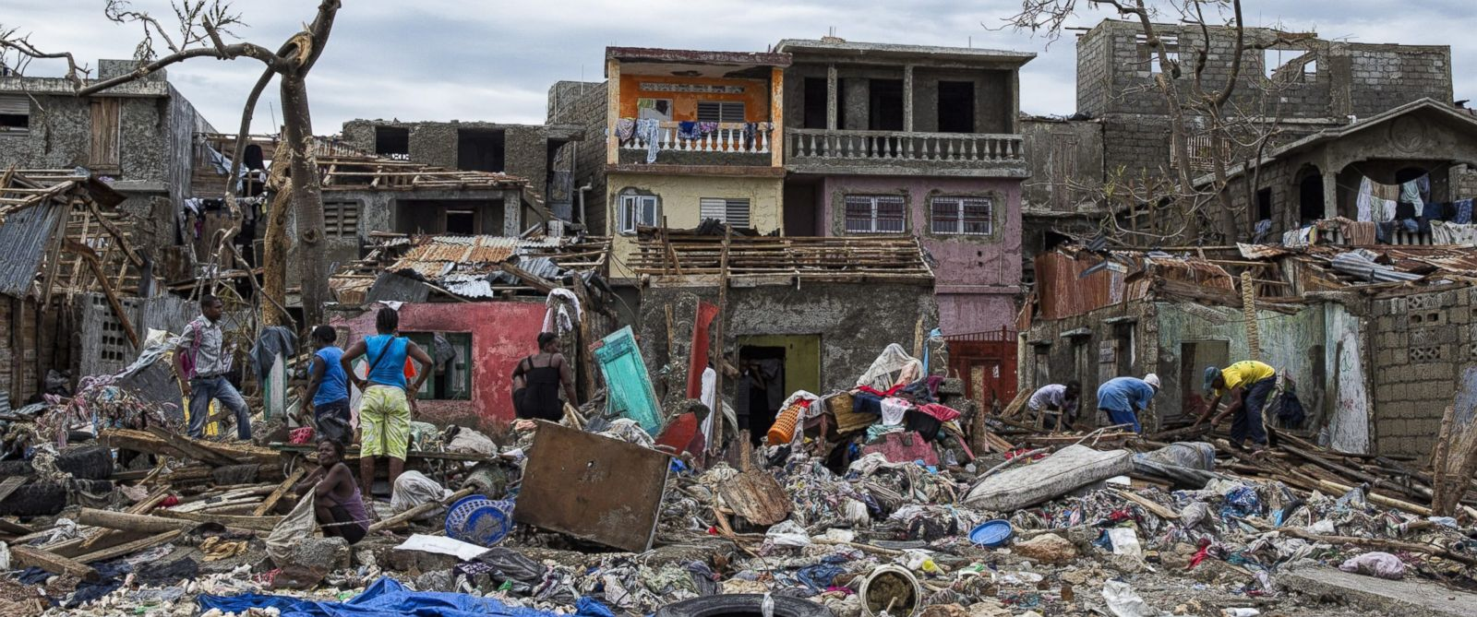
1. Damage from Hurricane Matthew in Haiti in 2016
Starter: Names for tropical storms in different parts of the world.
Atlantic Ocean & Eastern Pacific
Western North Pacific and Philippines
Indian and South Pacific Ocean

What are the key ingredients for the start of tropical storm formation?
Why is warm sea water (over 27°C) vital to tropical storm growth and expansion?
Why is the 'Eye Wall' so dangerous?
Outline the different ways that life and property can be under threat during a tropical storm.
What kills off a tropical storm and why?

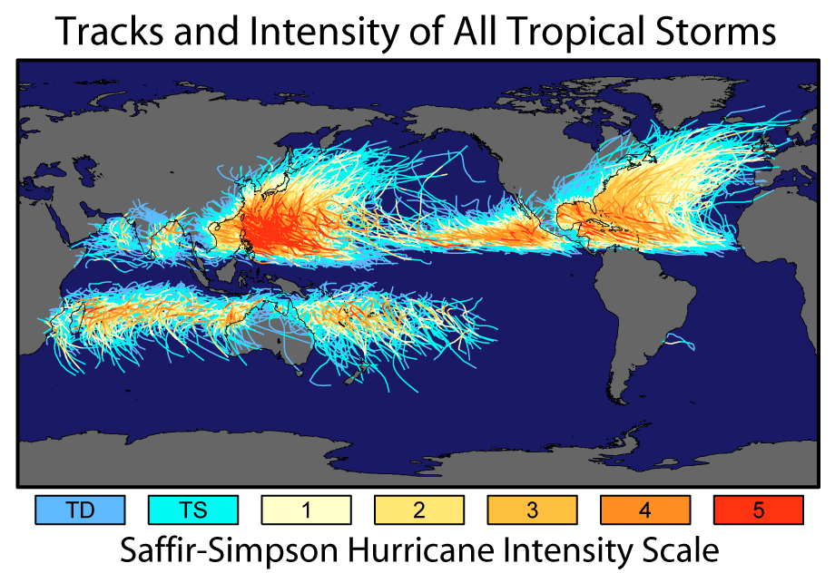
Task 1 - Comment on the spatial distribution of tropical storms globally. Ensure you use the terms in the section below to maximise the marks for your response
equator tropics highest density anticlockwise clockwise warm water band low density concentration Pacific Atlantic

Task 2a - Wind intensity is during a tropical storm is measured on the Saffir-Simpson Scale. The yellow (4) & red (5) tracks on your map indicate the most powerful storms.

i. Outline the areas of the world most prone to severe tropical storms?

