Introduction to Tornadoes
Year 7 Geography @ IST
Watch the video and then write down three sentences to describe a Tornado.

Sentence 1 –

Sentence 2 –

Sentence 3 –

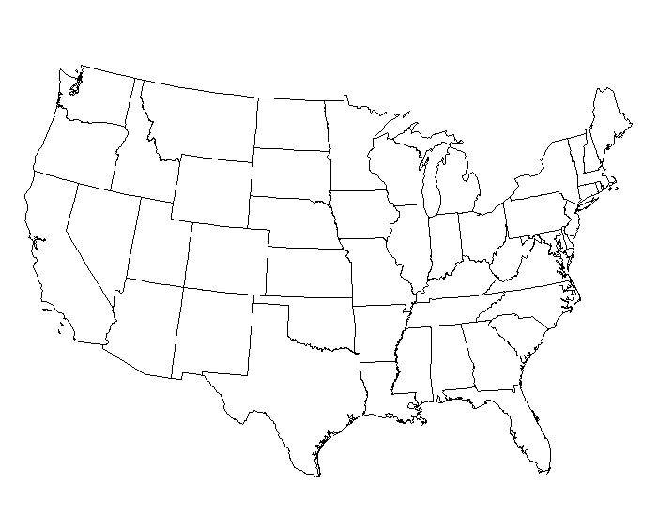
Using the Tornado Map on the board (PowerPoint) and an orange or red colour pencil, shade in the states of the USA that experience the highest frequency of tornadoes.

Using an atlas, name the four biggest tornado risk states to live in.
1
2
3
4

