IGCSE Geography Settlement – Urbanisation in Brazil.
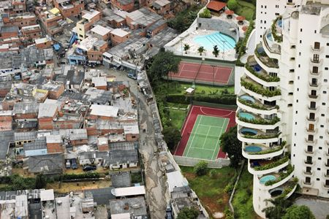
Starter – What does the term ‘urbanisation’ mean?

Task 1 – Using the CIA World Fact Book or Google Data, fill in the table below for Brazil.
Rank order in terms of total land area.
Main Languages spoken

Total Population

GDP per capita

Birth Rate

Death Rate

Literacy Rate

Life Expectancy

Homicide Rate

Task 2i – Write a description of the location of Brazil within South American and then Rio de Janeiro within Brazil.
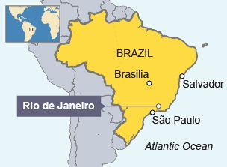
Task 2ii – Using the map below, write a description of the location of Rocinha in relation to the city of Rio de Janeiro.

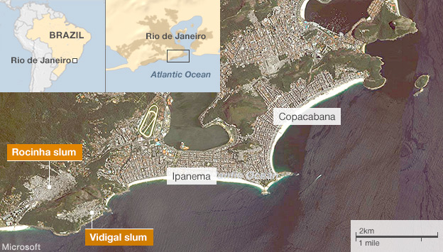
Task 3i – Define a shanty town (favela)

Task 3ii – Explain why favelas are known as informal settlements and why they have grown.

Task 3ii – State the types of materials that the houses are made from.

Task 3iv – In the space below, create a spider diagram to show why shanty towns like Rocinha grow rapidly.

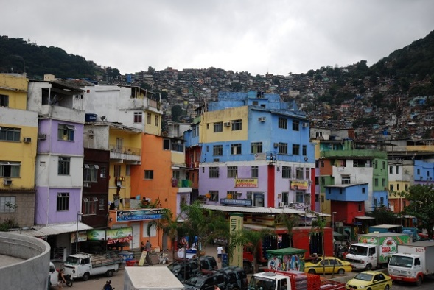

Task 3v - Make a list of five possible locations that you may find shanty towns. Think carefully about land values and accessibility.
Location | Why?
1.

2

3

4

5

​Task 4 - Check out the video to the right about the Olympics in Rio in 2016. Why are the government so concerned about favelas? What are they doing about it?

Do you think that favelas get bad publicity because of they way that they look? Is there more to these places than just drugs and guns? Go back to the Google Streetview on Geographypods and have a good look around.

