IGCSE Geography – Introduction to Globalization
Define ‘Globalization’

Starter: Use the two images on geographypods to explain the origins of the process of globalization. Make sure you make reference to the key character who is central in the artwork.
‘Godfather of Globalization ??
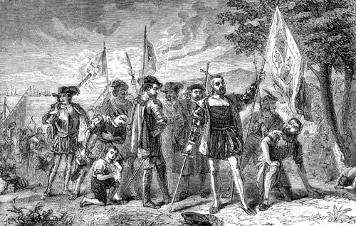
Task 1 - Study the familiar GIF on geographypods. It shows the process of continental drift over time. Can you think of any link between this process and globalization?

Task 2 is completed on a separate sheet

Task 3 - How globalized are you? Use your school laptop to take a photo of yourself with some of your possessions. Paste the picture into the space provided on your worksheet and annotate all the countries that 'you are wearing'. There might be more than one country represented by an item e.g. iPhone designed in California (USA) but manufactured in China.

Task 4 - Click on the link on geographypods to be taken to a BBC Bitesize resource about the positive impacts of Globalization. Make a note of these on your worksheet. When complete, advance to page 5 of the same site and do the same for the negative impacts.
Positive Impacts of Globalization | Negative Impacts of Globalization

Task 5 - Study the diagram and map above. It shows where parts from an A380 aircraft come from and the operations of Airbus around the world. Now watch the video below.

Outline the following:
- What has been the role of technology in enabling Airbus to operate across the world?
- What economic factors have contributed to their growth and spread?
- What have the impacts at a local, national and global scale been?

