IB Geography Hazards – Earthquake Hazard
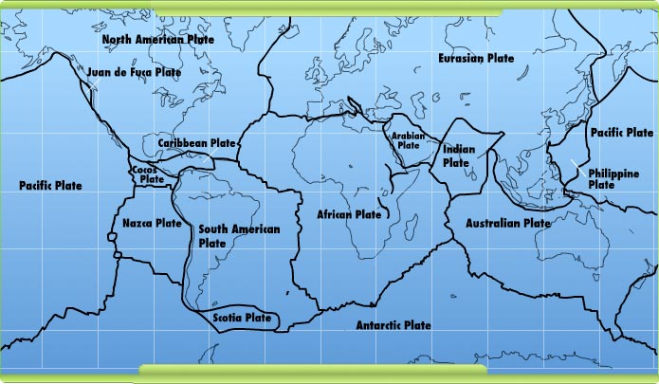
Above is a plate boundary map of the world. It shows the major plates and their margins (where they meet other plates). In Toulouse, we are located on the Eurasian Plate and our closest plate boundary is between the Eurasian and African Plate in the Gibraltar Straits (off the south coast of Spain). There are three types of plate boundary:

Earthquakes are common along all plate boundaries but those that are susceptible to large earthquakes are on transform boundaries – see the map below.

Using the video on YouTube, outline what the Richter Scale is. Make sure you explain what a single number increase means.

Complete this table using the YouTube video
Magnitude | Brief Description | Average Number of events per year (click here for link)
Less than 2.0
2.0 – 6.0
6.0 – 8.9

Complete the tasks below based on Historical Events – Magnitude 8 or more quakes since 1900

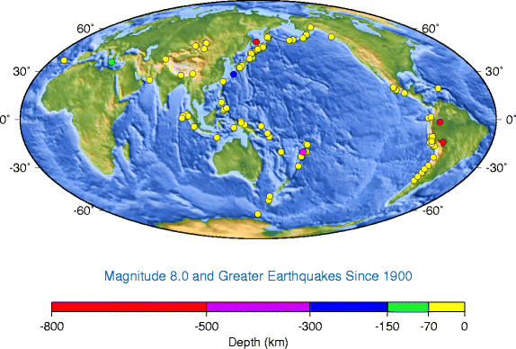

Describe the distribution of earthquakes of more than 8.0 since 1900.

Using this link, describe the distribution of magnitude 2+ that have occurred globally in the last 30 days.

