|  |
| --- |
| **IGCSE Geography – Agriculture - Intensive subsistence rice growing in south east Asia** |

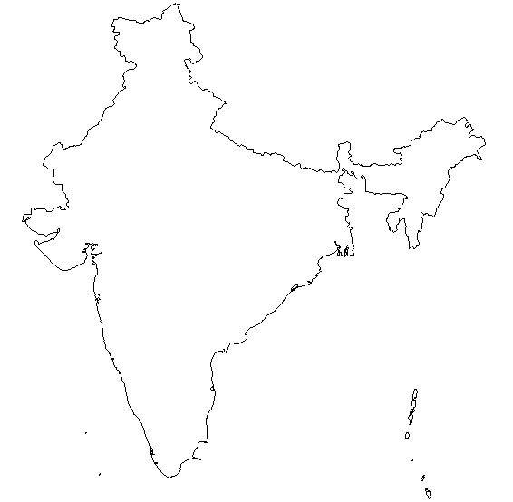

Task 4 - Problems of Rice Growing

Flooding :

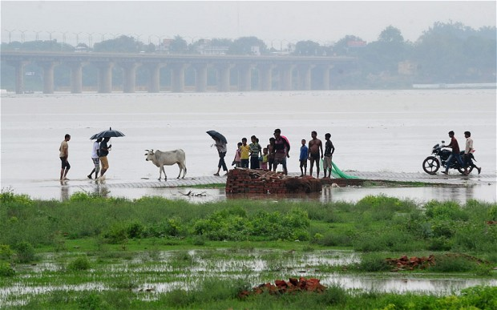

Drought

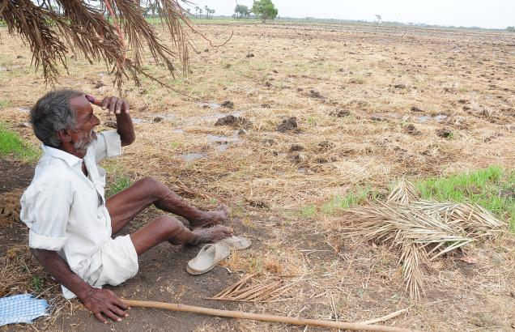

Population Growth

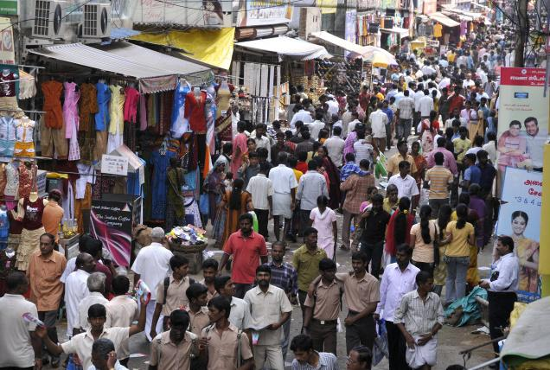

Task 3 – Complete these questions :

1. Why is rice so important as a food source in south east Asia ?
2. What does subsistence farming mean?
3. What else might a rice farmer produce?
4. How long does a rice crop take to grow (fig 4)



Task 2 – Sketch on the main features of the monsoon climate above.



Task 1 – Mark on the map the rice growing areas in India & Bangladesh

Task 5 - The Green Revolution. Create a spider diagram below to show the five features of the Green Revolution

Task 6 - Successes & Failures of the Green Revolution. Complete the table below.

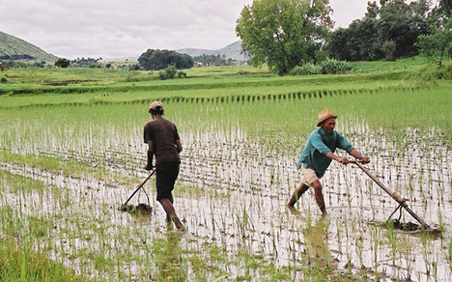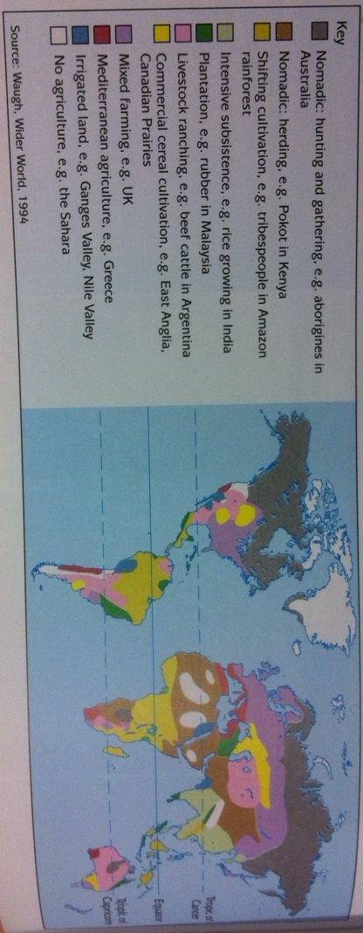

Task 8 - Using figure 3 on page 146, describe the world distribution of subsistence farming.

|  |  |
| --- | --- |
| Successes | Failures |
|  |  |

Task 7 - Define HYI