INPUTS, PROCESSES & OUTPUTS – IGCSE Agriculture

Objective: To be able to describe in general terms the main features of an agricultural system: inputs, processes and outputs

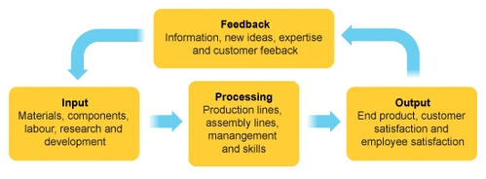
Inputs | Processes | Outputs

Feedback –

