Impact of Tourism on Destinations – Year 9 Geography

How does tourism develop in a destination?
The first to arrive are the ..
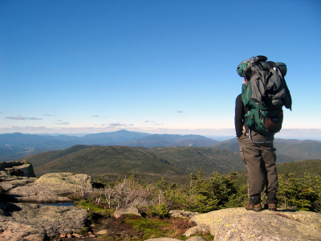

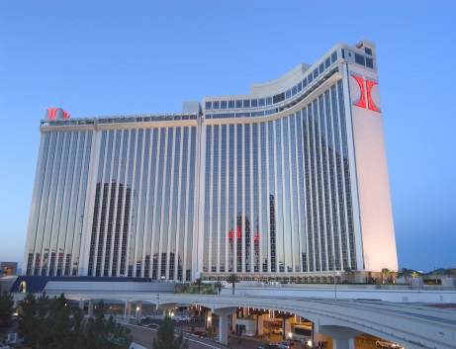
Effects of international hotel chains ..

Effects on local people are ..
Find an image of the ‘Padaung women’ and paste it to the left.
Who are these people?

Where do they come from?

Why are they affected by tourism?

Paste image here….

Paste your image here..
Find a suitable image that shows ‘Mass Tourism’, paste it to the right and explain how it shows it.

What are the main features of mass tourism?

How much of your safari holiday money would go to the Masai tribe?

My Recent Experience of being a tourist.
In the space below, copy and paste a picture of you on a recent holiday. Annotate around the photo all the positive and negative factors associated with your holiday. You’ll have to think carefully about this.
Your photo here…
Location: Date:

