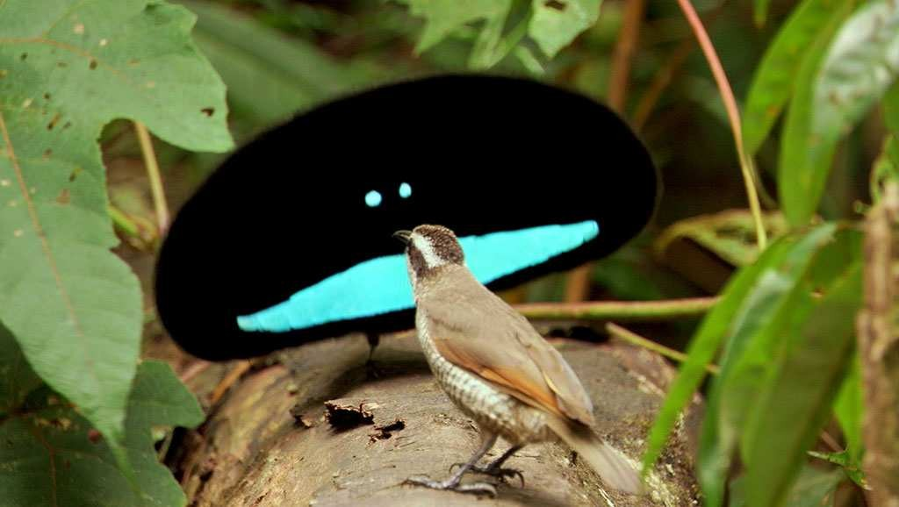
Name ?????
Planet Earth – Jungle / Tropical Rainforest

While watching the BBC Planet Earth Jungle documentary answer the following questions.

00:00:00

Six geographical locations/countries are mentioned during the documentary. See if you can list them all:
1
2
3
4
5
6

Tropical rainforest is described as the Earth’s ‘hot house’. Why?

What percentage of the Earth is covered by tropical rainforest?

What percentage of the Earth’s animal species are found in tropical rainforests?

00:04:30

What percentage of sunlight gets to the forest floor?

One hectare of rainforest has how many species of tree?

Why is that number so much higher than you would find in a hectare of forest in Europe or North America?

00:06:00

All plant species on the forest floor are competing for …

Explain how each of the following plant types compete:
Hardwoods
Vines
Climbers
Pioneer Plants such as Macaranga

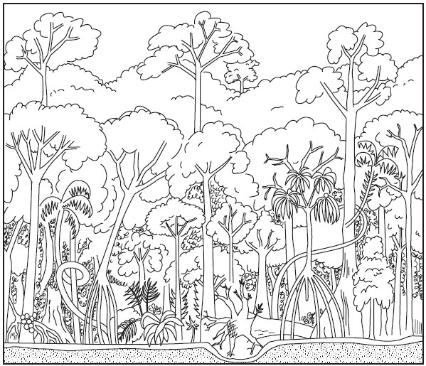

00:09:00

Label onto the diagram below the typical structure of a tropical rainforest.

00:21:00

How many metres of rain does the rainforest receive a year?

Where does half of that rain come from? What sort of rainfall is that?

Why are fungi important to the tropical rainforest system?

00:28:00

Why are parasites important to the tropical rainforest system?

00:30:00

Flying Lemurs are ‘specialists’. What is their specialism?

How does the Flying Lemur’s specialism benefit them?

Pitcher Plants are also ‘specialists’. What is their specialism?

How does the Pitcher Plant’s specialism benefit them?

