IGCSE Geography - Biomes – Why are they located where they are?

A biome is a major regional group of distinctive plant and animal communities best adapted to the region's physical natural environment, latitude, altitude and terrain factors. A biome is composed of the vegetation and all associated fauna (animals, insects etc) and soils, but can often be identified by the vegetation type. | Source: Wikipedia

Reason 1 – Levels of solar radiation
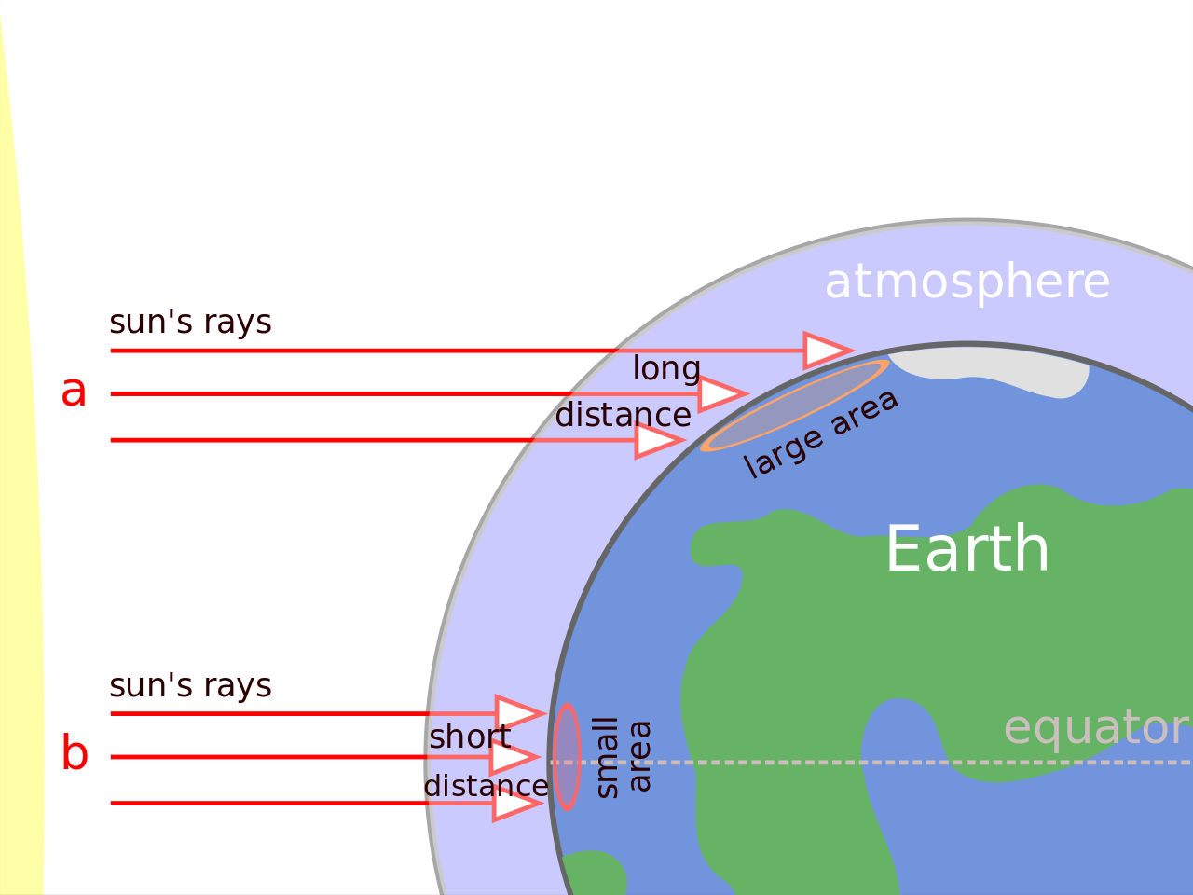

Why does the Equator receive more solar radiation than the Poles?
How does the level of solar radiation arriving upon different parts of the earth's surface affect the biome located there?

Reason 2 – Prevailing winds
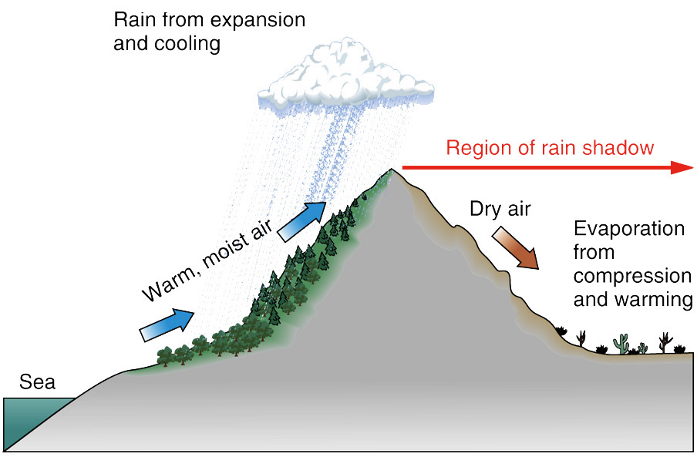
What is a rain shadow and how does it affect the biomes in that area?

Reason 3 – Oceanic Circulation
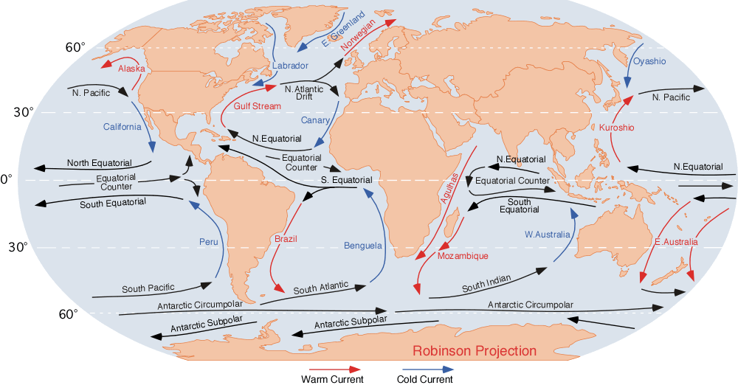
How does the 'North Atlantic Drift' keep France & Western Europe warmer than it should be?

Reason 4 – Altitude
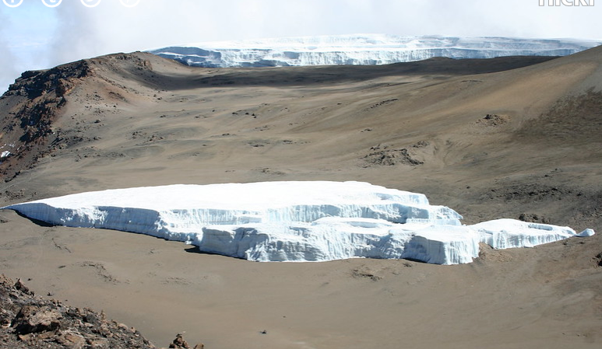

The image above shows the Furtwangler Glacier on Mt Kilimanjaro. The location of the glacier is very close to the equator. Explain why there is a glacier at such a warm latitude.

Reason 5 – atmospheric cells
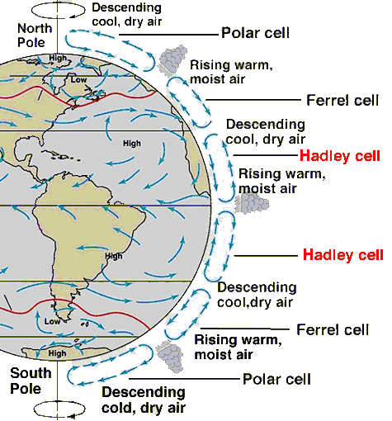

How does the presence of atmospheric cells explain the location of deserts and tropical rainforests?

