IGCSE Geography – Theme 2 - Climate - Recognising Clouds – Link to Met Office Page here

 | High Altitude Clouds |  | Mid Altitude Clouds |  | Low Altitude Clouds

Name of Cloud | Photo | Features | Associated Weather
CIRRUS

CIRROSSTRATUS | 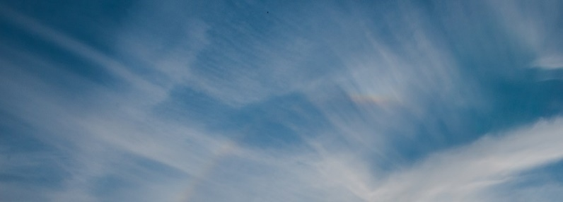
CIRROCUMULUS | 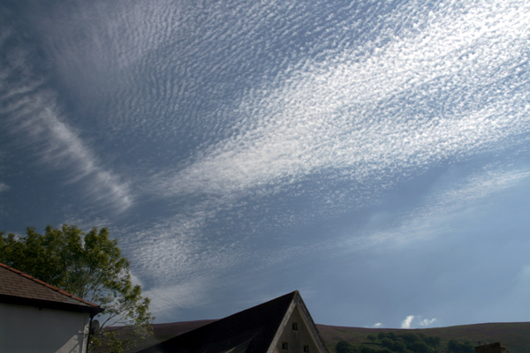
ASTROSTRATUS | 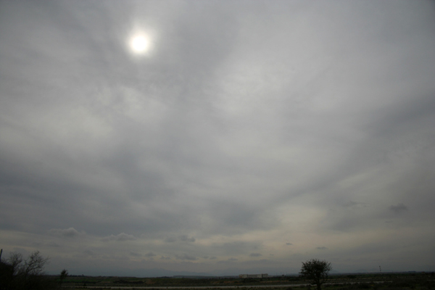
ALTOCUMULUS | 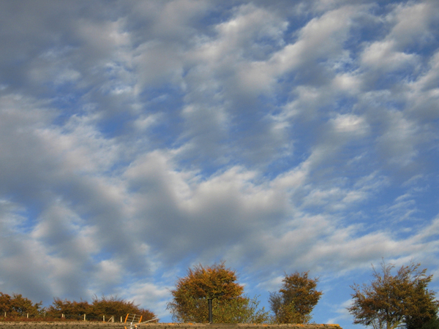
NIMBOSTRATUS | 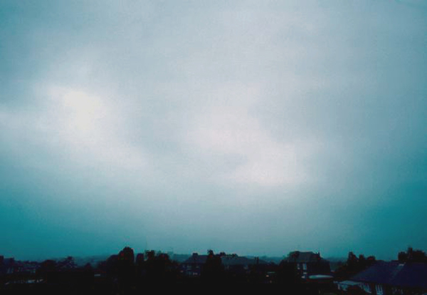
CUMULUS | 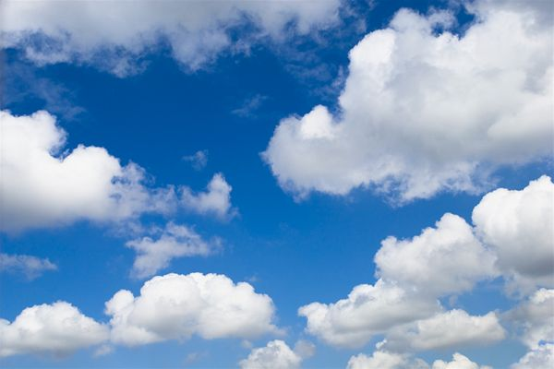
STRATUS | 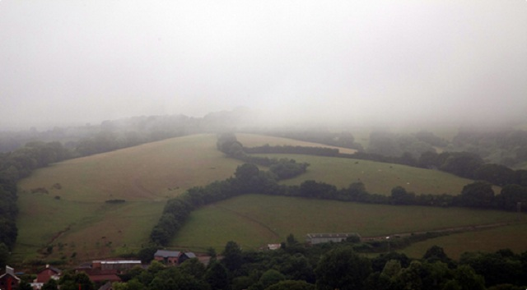
Cumulonimbus | 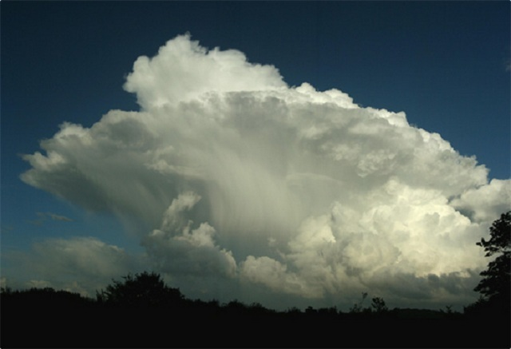

Today, outside my school, the clouds are (go and have a look):
Add annotations around your photo.
Image here

