IGCSE Geography – Theme 2 – Climate – Introduction to Clouds

- Draw you diagram from memory in the space below

- In less than 50 words, explain how clouds can form (see video on geographypods).

- Why are clouds white?

- Take notes on the five ways that clouds can form from the Met Office weblink on geographypods.

Surface Heating
Topography

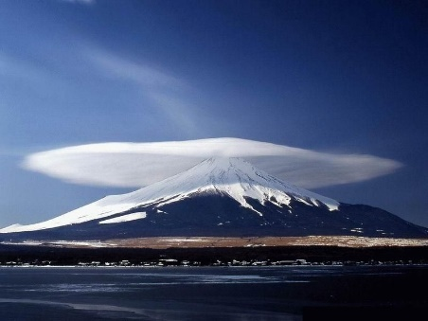
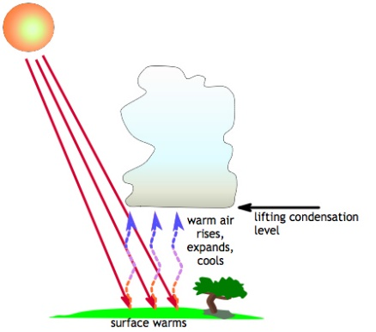

Frontal
Convergence
Five ways that clouds form

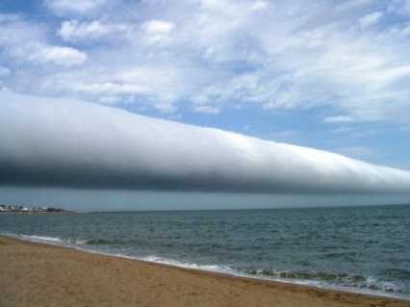
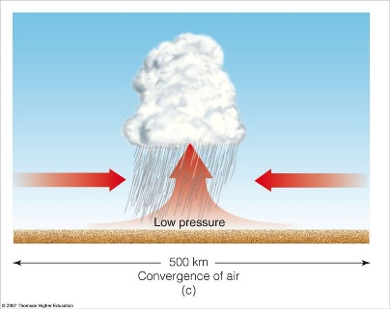

Turbulence

