IGCSE Geography – How Rivers Change From Source to Mouth
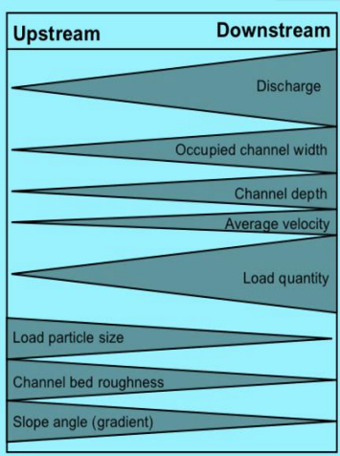
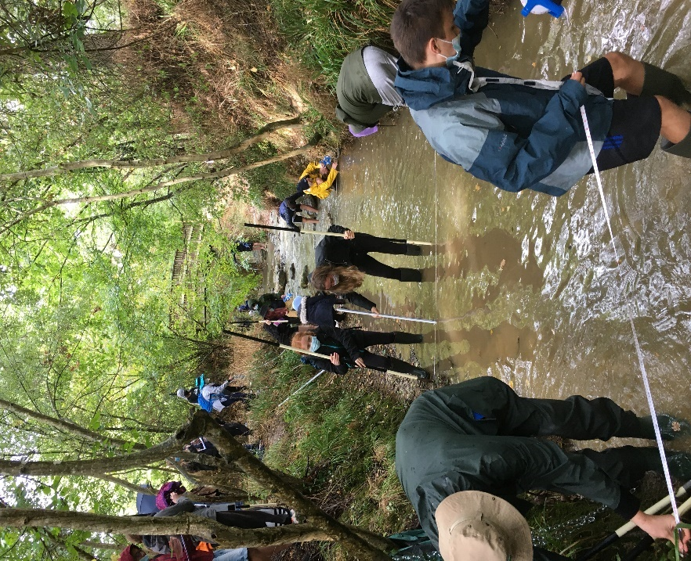

Watch the following video - https://www.youtube.com/watch?v=u_ReEAsFVY0

What does the long profile of a river mean?

Pause the video when you get to 1:16. Draw (don’t copy & paste) the long profile of a river into the space on the next page. Add labels and axes titles too.

Drawing here of long profile of a river.

Upper course – explain the steep gradient of the land in the upper course.

Middle course – explain the changes in the middle course of the river

Lower course – explain the changes in the lower course.

Starting at 2:23, draw explain how the cross-profile of the river changes as you move from the upper to the lower course of the river

Upper course diagram | Middle course | Lower course
Explanation | Explanation | Explanation

Starting at 4.24, listen carefully to the rest of the video and make notes on how the different features of the Bradshaw model

Process | Definition | How it changes as the river travels downstream.
Discharge
Erosion

Transportation

Deposition

Load Size

Average Velocity

STOP AT 10:00 minutes.
For the following features of the Bradshaw Model, please refer to this document on geographypods. https://www.geographypods.com/uploads/7/6/2/2/7622863/bradshaw_model_presentation_for_students.pdf

Occupied Channel Width
Channel Depth
Load Quantity
Channel Bed Roughness
Slope Angle (Gradient). | The angle between different points of the river.

