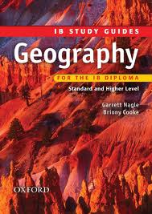

**IB Geography**

**International School of Toulouse**

**Mock Examination – January 2013**

Paper 1 – 1 hour 30 minutes (SL/HL)

Paper 2 – 1 hr 20 (SL) 2 hrs (HL)

Paper 3 – 1 hr (HL)

**Student Revision Pack**

Name : _________________________

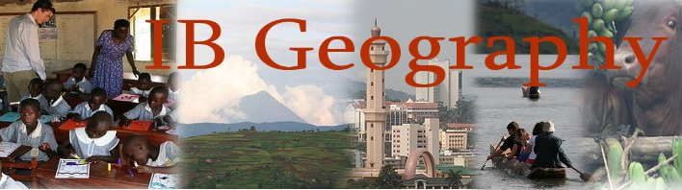

**Paper 1 – HL/SL Students**

**Core Themes – Patterns and Change – 70 Hours**

All students sit paper one and there is no difference in the number and difficulty of questions to be answered. Use the IB study guide, your case study sheets and your **UP TO DATE** folders to guide you through the revision process. Using the IB revision guide contents page, you can see that we have completed the following sections:

1. Populations in Transition p.6-21
2. Disparities in Wealth & Development p.22-31

This paper will take **1hr30** to complete and there will be four sections to complete.

You need to focus your revision on the 2 main key areas outlined above. However, ensure you focus on the following:



1. **Populations In Transition (30 mins)**

There will be a structured question section which asks you to respond to a graph/chart/photo, then tests your knowledge further

* Understand birth rates, death rates, birth ratio, natural increase, mortality rate, fertility rate, life expectancy, population momentum (look at annotated global patterns graphs)
* Understand HDI and how it is calculated
* Pro and Anti Natalist Policies. Be very familiar with both.
* What are the impacts of youthful and ageing populations and know your case studies.
* Migration case studies (internal & external) pros and cons to origins and destinations (SEEP) and the impacts on origin and destination.

1. **Disparities in Wealth and Development (30 mins)**

There will be a structured question section which asks you to respond to a graph/chart/photo, then tests your knowledge further

* What is the HDI, GNI, GNP, GDP and how is it calculated?
* Understand the benefits & limitations of using the above features as a measurement of development
* How do disparities occur? Ethnicity, residence, parental education, income employment and land ownership. Group work case studies.
* Revise the 7 Millennium Development Goals and the progress that has been made on each. Make sure that you have your case studies on each and link to factors that are hindering their progress
* How can global disparities be reduced? Aid and Market Access, Debt Relief and Remittances. (see sample essay on the revision page of the website) Group work case studies. Live Aid, Live 8, Remittances to Africa, Make Poverty History etc.

**Paper 2 (SL/ 1H15) (H/L 2h00)**

1. **Freshwater (HL & SL Students) 40 minutes**

* Understand how the hydrological cycle and its different features. Make sure you know the main processes and definitions inc. infiltration, throughflow, baseflow etc and positive and negative feedback.
* How can flood plains be managed and how does human activity affect the flow of water through the system.
* How do humans try to stop flooding and what are the pros and cons doing so and doing nothing? (corseted & free reign)
* Revise your Artesian basin case study and ensure that you can explain its physical formation and workings.
* Look at agro-chemical runoff and eutrophication. Make sure your case studies are up to date and you have all the key details.
* Study your case study of a national/regional water conflict (Israel & Gaza Strip)

1. **Sport, Leisure & Tourism (HL & SL Students) 40 minutes**

* Definitions of sport, leisure and tourism.
* The short and long term patterns and trends in international tourism
* Know the key features of mass tourism, ecotourism and heritage tourism.
* Explain the term ‘Carrying Capacity’ and how it can be influenced by human & physical factors.
* Know and explain the factors that affect participation and success in the sports that we have studied (Premiership, Grand Prix & World Cup)
* The influences on the growth of sports, recreation and tourism

**SL Students will finish their examination at this point.**

1. **Hazards & Disasters Risk Assessment & Response (HL 40 mins)**

* Know the definitions of hazard risk and probability and how that applies to each of your case studies.
* Understand the three approaches to hazard vulnerability and give examples of where those approaches may be found.
* How are different hazard events measured?
* Revise your drought and tropical storm case studies (MEDC & LEDC) including vulnerability, risk reduction and risk assessment for each.
* Hazard Prediction and preparation for each of the four hazards and their contrasts between MEDC/LEDC
* Look carefully at your AZF/Chernobyl case study.

**Paper 3 HL – 1 Hour**

* Cultural diffusion – study all aspects in the section Socio-Cutural Exchanges
* Effects on the environment – agro-industrialization, e-waste and trans boundary pollution event.
* Internet and mobile phone advancements and how they drive global interactions between core and periphery
* General read-though and understanding of the major case studies in your revision booklet.

Planning ahead …….

H/L & S/L Paper 1 - Exam Date – **Monday 7th J**anuary 2013

H/L & SL Paper 2 – Exam Date – **Tuesday 8th** January 2013

HL & S/L Paper 3 – Exam Date - **Tuesday 15th** January 2013

If you need any help with revision or need to contact Mr Podbury you can on the following address: [podbury_m@intst.net](mailto:podbury_m@intst.net)

Alternatively, get in contact with me using the Facebook group page:

Checklist before leaving school: I have got,

Folder

Work Book

Case Study Booklet

IB revision guide

Copies of texts needed

