IB Geography – Hazards & Disasters
Case Study Summary Sheet for the AZF Human Induced Disaster
Where did it happen?
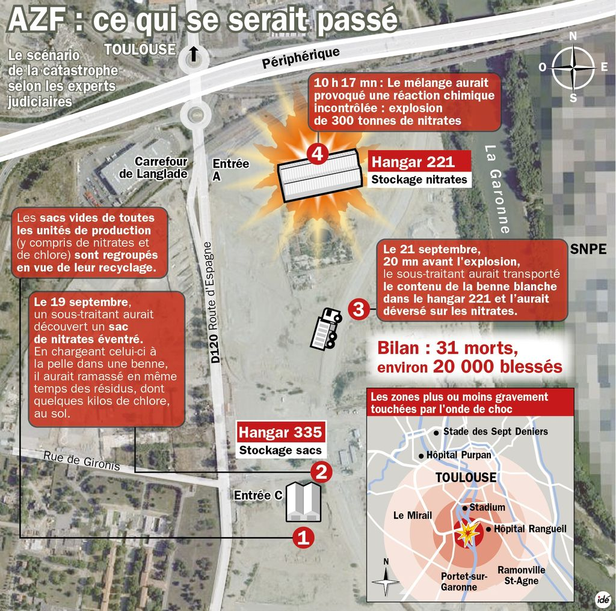
Toulouse is located in the ……….

AZF was located in ……..

CIA Fact Box – France Need To Know
Indicator | Values (2014 estimated)
GDP per capita PPP
People Living in Poverty (less than $2 per day)
Access to Clean Water
Life Expectancy
Literacy Rate
People Per Doctor

When did it happen?
Date.
Duration.

Why did it happen?

Who was affected by it happening?
Social Impacts | Economic Impacts
Environmental Impacts | Political Impacts

What happened? *Leave this until we complete the next section on risk assessment and adjustments & responses to hazards
Management of the AZF Explosion in Toulouse
Before the event

During the event

After the event -

Planning, preparation, prediction, hazard mapping, evacuation, warnings.

Help with recovery, aid - local, regional and international, role of NGOs.
Rescue (short) Rehabilitation (Medium) Reconstruction (Long)

